
The eBooks below contributed to the movement that has changed the world of science today. These books confirm the literal Bible and disprove evil liberal junk science, including evolution, homosexuality, transgenderism and climate change. These eBooks return science to its original goal, to boldly seek the truth. The same goal as given to Christians in the Bible. Both goals lead to the same creator God.
These eBooks include chapters on repeating scientifically proven miracles, God's incredibly designed nano-machines that build and repair our body, mega-machine designs that God used to create the universe with unimaginable precision and complexity, plus archeological discoveries that confirm the literal Bible including ancient Israel, the Exodus of Moses and Noah's Ark.
These eBooks also reveal the incredible true heroic history of Christianity, and evil history of homosexuality, Marxism, Islam and slavery that liberals desperately try to hide. These eBooks also scientifically verify the literal Bible, that shows where great sin will lead the world... into the imminent end times and eternal hell. Plus, the amazing eternal future in Heaven for those who join me to end these great sins and follow Jesus.
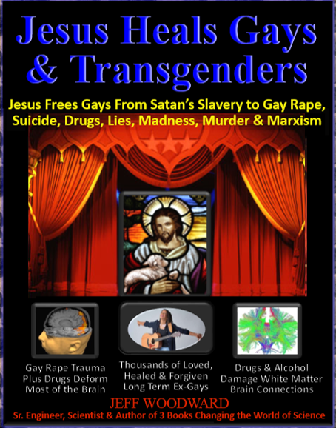
Jesus Heals Gays & Transgenders eBook free download at godrevealed.net
This eBook relies on rigorously proven science, historical evidence testimonies from thousands who experienced long-term freedom from criminally forced, deadly addictive entrapment of homosexuality & transgenderism.
This book confirms what the Bible scriptures literally stated thousands of years ago; that “homosexuals”, “men who have sex with men” or “sodomites" are “error(s)” and “perversion(s)” that are “shameful” and an “abomination” to God. Transgender men who “wear women’s clothing… God detests”. God said they will not enter Heaven unless they leave these deadly paths, through Jesus who is willing to heal, cleanse and save them (as God revealed to the Apostle Paul in I Cor. 6:9-11, Rom. 1:27, and Moses Deut. 22:5 NIV/NASB & Lev. 18:22 KJV/NASB).
It is not acceptable to withhold this information from gays and transgenders and the families that care about them, that is hate, not love. Enduring persecution to free people from this deadly destructive sex slavery is showing love.
Today there is a vast amount of data that scientifically proves homosexuals & transgenders are “slaves to sin” and Satan as the Bible clearly states. Jesus stated 10 times that all types of unrepentant sin led to a literal “eternal” “lake of fire”. Today we can scientifically prove that this exists inside the entire Earth, from nuclear reactions that will last billions of years. (Rom. 1:22-33, John 8:34, Deut. 32:22, Mark 9:43-49, Rev. 14:9-11, 20:10,15 KJV/NIV)
This book proves those trapped in the gay lifestyle use criminal conversion therapy to convert tens of millions of straights into gays and transgenders worldwide, through rampant: child molestation, drug-induced gay rape, exposure to porn, drug addiction, alcoholism, violence, broken families, Marxism and the occult.
Science today proves that combinations of these causes often produce homosexuality & transgenderism, and result in most sections of the brain becoming visibly deformed and damaged over time, as proven by (fMRI) functional Magnetic Resonance Imaging and diffusion tensor imaging of the brain’s white matter connections.
These evils are an epidemic today and nearly happened to me as a teen. I barely escaped from an unsuccessful knock out drug gay rape attempt at a work party, by a secretly gay fake friend and boss.
Unfortunately, my brother who was a kind and innocent Christian heterosexual, fell prey to molestation and later to drugged gay rape sodomy that is rampant today. Over the decades this led him to alcoholism, drug abuse, pornography, raging anger, radical liberalism, satanism and mental illness… the same patterns as in many homosexuals. I later personally witnessed the satanic roots of homosexuality, as I fought against it.
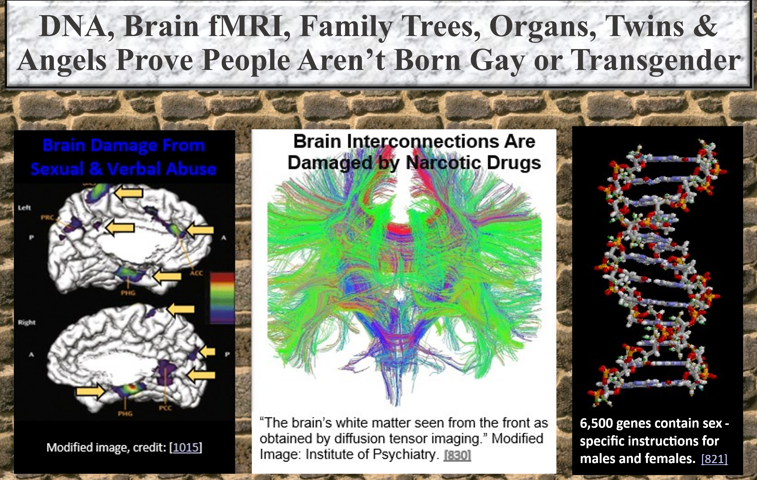
But release is possible through Jesus Christ, who heals and reverses their brain damage over time… and often instantly. Jesus who raises the dead, can easily heal brain damage inflicted on the brains of homosexuals and transgenders, who cry out to Jesus per their published testimonies. They often report seeing or hearing Jesus when their healing occurs. Jesus cleanses them, forgives all their sins and they experience unconditional love. This occurs because Satan has no power over Jesus. Jesus died for them and all other sinners.
Those whose mind has been restored find loving support and encouragement in gospel-centered biblical churches today. Conservative Christians who follow biblical authority are becoming the new slavery abolitionists, fighting against the modern-day worldwide satanic sex slavery of homosexuality and transgenderism. Conservative Christians free the gays and transgenders that liberals have criminally enslaved. I want them to be restored, cleansed and released from their sin, to enter eternal Heaven.
But Jesus literally said in many Bible verses that if you follow Him, those living in sin would be “offended”. The Bible also said that Jesus offended everyone. That is why they crucified Him… and most of His Apostles. (Mark 4:17, 14:27,29, Mat. 10:16, 13:57, 15:12, 24:10, 26:33, John 3:19-21 & Luke 21:12 KJV). If you are not offending people in your evangelism, you are not doing the work of Jesus.
In fact, the Bible said that before the end times, everyone would be “offended” by the words of Christ. We are seeing the literal fulfillment of this Bible prophesy today where everyone is “offended” by the words of Jesus. We see a wicked world that celebrates every form of evil. This shows the return of Jesus is near.
The Bible also said that if you know the truth that will free others from sin, but do not share it with those living in sin, then their judgement will be upon your head. (Ezekiel 3:18-21 KJV) Jesus also said that those who censor, prohibit and block Christian evangelism will be in the lowest hell. (Mat. 10:14-20 KJV)
Democrat leaders today force same evil beliefs as their direct predecessors, WW2 NAZIs. For example, the recent socialist administrations of Biden, Kamala Harris, Nancy Pelosi, Hillary Clinton and Obama:
- Violently forced their beliefs using black clad BLM and Antifa rioters that used assault and murder.
- Appointed corrupt district attorneys & judges that harshly sued or jailed those who opposed evil laws.
- Consider the master race to be gays and transgenders, that were the only people they hired.
- Had fake spouses to appear sexually normal and hide their bi-polar or schizophrenic mental illnesses.
- Are addicted to: child porn, unaccompanied minor sex trafficking, rape of teens and rampant drug use.
- Promoted heinous medical experiments on aborted baby body parts, they don’t consider human.
- Attempted to pass evil laws to legally force all healthcare workers nationwide against their will, to participate in child mutilating mass murder abortions, transgender surgeries, plus euthanasia suicides.
- Force constant school indoctrination of evolution, evil spirits, witches, magic, dragons & evil religions.
- Were angry dictators as past COVID lockdowns revealed and forced terrible socialized healthcare.
- Regularly spoke of jailing or exterminating all White males & Christians, after confiscating their guns.
- Passed illegal laws to fire all Christians, plus removed all their crosses, Bibles, books, statues & prayer.
- Partnered with radical Muslim leaders who stated their goal was to exterminate all Christians and Jews.
- Are militant vegetarians who live in opulent wealth stolen from the poor. They are often artists.
- Released all violent criminals from jails, while filling maximum security jails with non-violent Christians.
- Admitted engaging in occult ceremonies, speaking to demons, or admitted they are possessed.
- Follow Marxism where Karl Marx admitted in his poems that he: worshipped Satan who put a bloody sword in his hand, knew he would go to Hell, plus his number 1 goal was to eliminate God.
- Corrupted churches and Bibles by forcing the acceptance of evil homosexuality and child gay rape by gay priests in churches, that teach that sin and Hell do not exist & Jesus is not the only path to Heaven.
- Attend Gay Pride events that celebrate past riots, where adult gays violently defended their cross-dressing gay child prostitute from arrest, at the Stonewall Inn, a mafia owned gay bar in 1969 NYC.
- Were anxious during past Biden administration to start nuclear World War 3, to gain one world control of the Earth and kill billions of people, to save Earth from fake global warming. They claim they will prevent the apocalypse by carrying out the apocalypse… by eliminating 90% of the world's population.
- Liberal billionaire & Marxist socialist leader George Soros admitted that as a child he collaborated personally with World War 2 NAZIs during the holocaust, to help steal property from other Jews. Today demon possessed George Soros thinks he is "some kind of god", while funding every form of evil.
Overwhelming evidence proves that past World War 2 era NAZI leaders (the National Socialist German Worker’s Party), did the same evil things:
- NAZIs used murderous Brown Shirt street rioters to gain power, assault & murder those who opposed.
- NAZIs installed corrupt black clad SS officers and judges who enforced evil laws and killed opposition.
- NAZIs confiscated all guns from the Jews, so they could later exterminate the Jews without resistance.
- NAZIs partnered with radical Muslim leaders, who also publicly stated their goal was to kill all Jews.
- NAZIs forced their belief in evolution, plus rampant murders from abortion, suicide, euthanasia, and ordered methamphetamine drug use for all NAZI soldiers, enabling their atrocities.
- NAZIs were gay, often with fake wives, met in gay bars, were bi-polar or schizophrenic, occasionally dressed and acted feminized in private with their gay partners & were rampant child and teen rapists.
- NAZIs considered the master race to be White Aryan HOMOSEXUALS, the only people they hired.
- NAZIs lived in opulent wealth stolen from the poor. The NAZIs also supported hateful angry feminism.
- NAZIs released all sex criminals from jail, that included many future NAZI leaders.
- NAZIs forced state run socialized healthcare & education designed to constantly indoctrinate children.
- NAZIs followed Marxism, where Karl Marx admitted he followed Satan, #1 goal was to eliminate God.
- NAZIs killed 10% to 30% of all Christian pastors in occupied nations, who opposed evil corrupted NAZI bibles, where sin and Hell did not exist. NAZIs removed all crosses from churches and authentic Bibles.
- NAZIs conducted heinous medical experiments on Jews, who they didn’t consider to be human.
- NAZIs fought World War 2 to gain one world control of the entire Earth, that led to 60 million deaths.
Hitler lived as a gay child prostitute, alone with no parents in a flop house with many adult gay men. He became a do-nothing hippie teen, regularly read demonic occult and gay porn books until his death and was an amateur artist. As an adult, he became an angry vegetarian dictator who rampantly raped little children, girls & boys. He attended famous annual German gay pride event called Bayreuth, a notorious international gathering for prominent pederast (child raping) homosexuals. He later claimed to be a Hindu god, used mind altering methamphetamine drugs & claimed a demon told him that he would save Germany. Hitler murdered fellow NAZI homosexual leader Rohm, when Rohm became too powerful & threatened to overthrow Hitler.
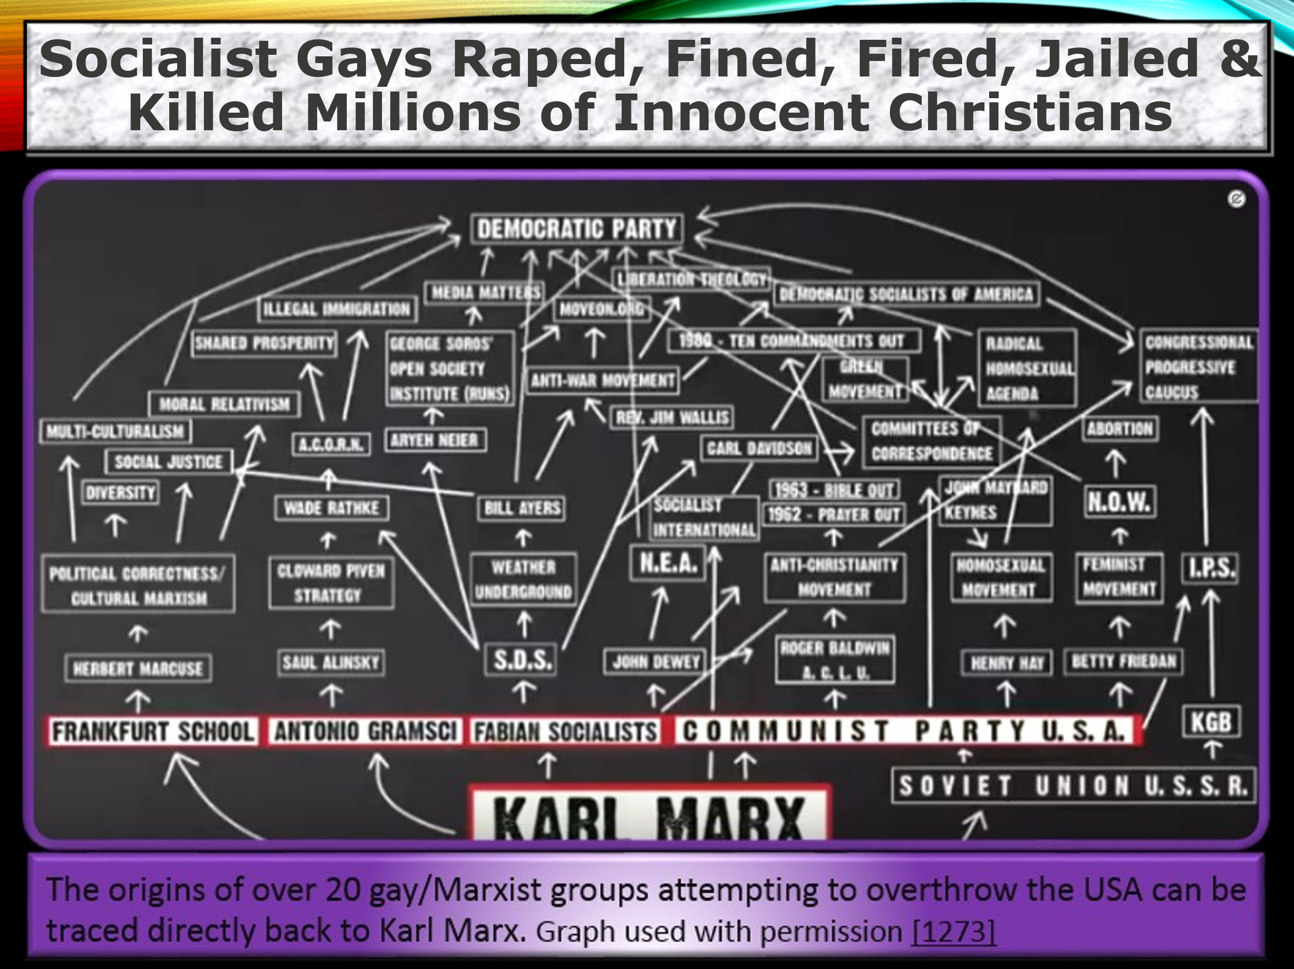
Forcing people into homosexuality, transgenderism, occult religions, abortion or Marxism is the stated goal of the Marxist Manifesto, UN Agenda 21 plan, witchcraft & occult books, Saul Alinsky’s book “Rules for Radicals”, Gramsci’s stealth internal Marxist revolution, early transgender icon and NAMBLA promoter Henry Hay, the Homosexual Manifesto and comments from other leaders of these groups.
Marxist liberal leaders today are often former leaders, members or supporters of openly butch child gay raping groups that include GLSEN, the Human Rights Campaign (HRC) and NAMBLA.
Videos & books:
- Scott Lively: "The Pink Swastika" scottlively.net/scott-lively-books/the-pink-swastika/
- Curtis Bowers "China's Plans for America“ & “Agenda” youtube.com/watch?v=Y0KmUYvk6EU
- Trevor Loudon: "Attempted overthrow of US by over 20 Marxist groups", "White House Reds", "Stealth", "Communist Agenda Behind the Climate Movement"
- [1020] [1023] [1026] [1099] [1103] [1138] [1175] [1176]

End Time Events, Heaven & Hell eBook free download at godrevealed.net
This eBook scientifically proves literal end time Bible prophesies are being fulfilled today. The prophecy puzzle pieces from every book of the literal Bible fit together perfectly. They all describe the same detailed sequence of end time events, Heaven & Hell.
The Bible stated that rampant abominable sin from Satan with a worldwide falling away from God will lead to the beginning of the end time apocalypse, exactly as we find today. Fulfilling Bible prophesy, Arabs worldwide are drunk with anger, attacking Israel, led by Iran (formerly Persia) and Russia. There is mass persecution, imprisonment and murder of Christians worldwide.
There are rampant world famous Hollywood great whores and homosexuality, plus rampant rapes, murders and bestiality promoted by evolution. Today Satan’s occult is the fastest growing religion worldwide… and a one world government led by a one world leader, is the stated goal of deep state liberal socialists today, who want to be this leader.
The world today, before the end times, is full of satanic magic, madness and mind damaging drugs, that cause rampant violent crime. The evil world today resembles the evil world before God’s judgement in Noah’s Flood, where magic, alcohol, drug paraphernalia, drug pipes, mind damaging drugs and weapons were often found. Most pre-flood bodies of this time, including Iceman Otzi, violently died from spear, arrow or axe wounds. (“The Archeological Evidence of Noah’s Flood” Philip Williams, pg. 143,154-156)
Bible end time prophesy gives an incredibly accurate description of the scientifically proven, catastrophic worldwide effects, from a future “huge mountain, all ablaze”, a “great star, blazing like a torch” that "fell from the sky” near the middle of the end times. This “rock was cut out, but not by human hands”.
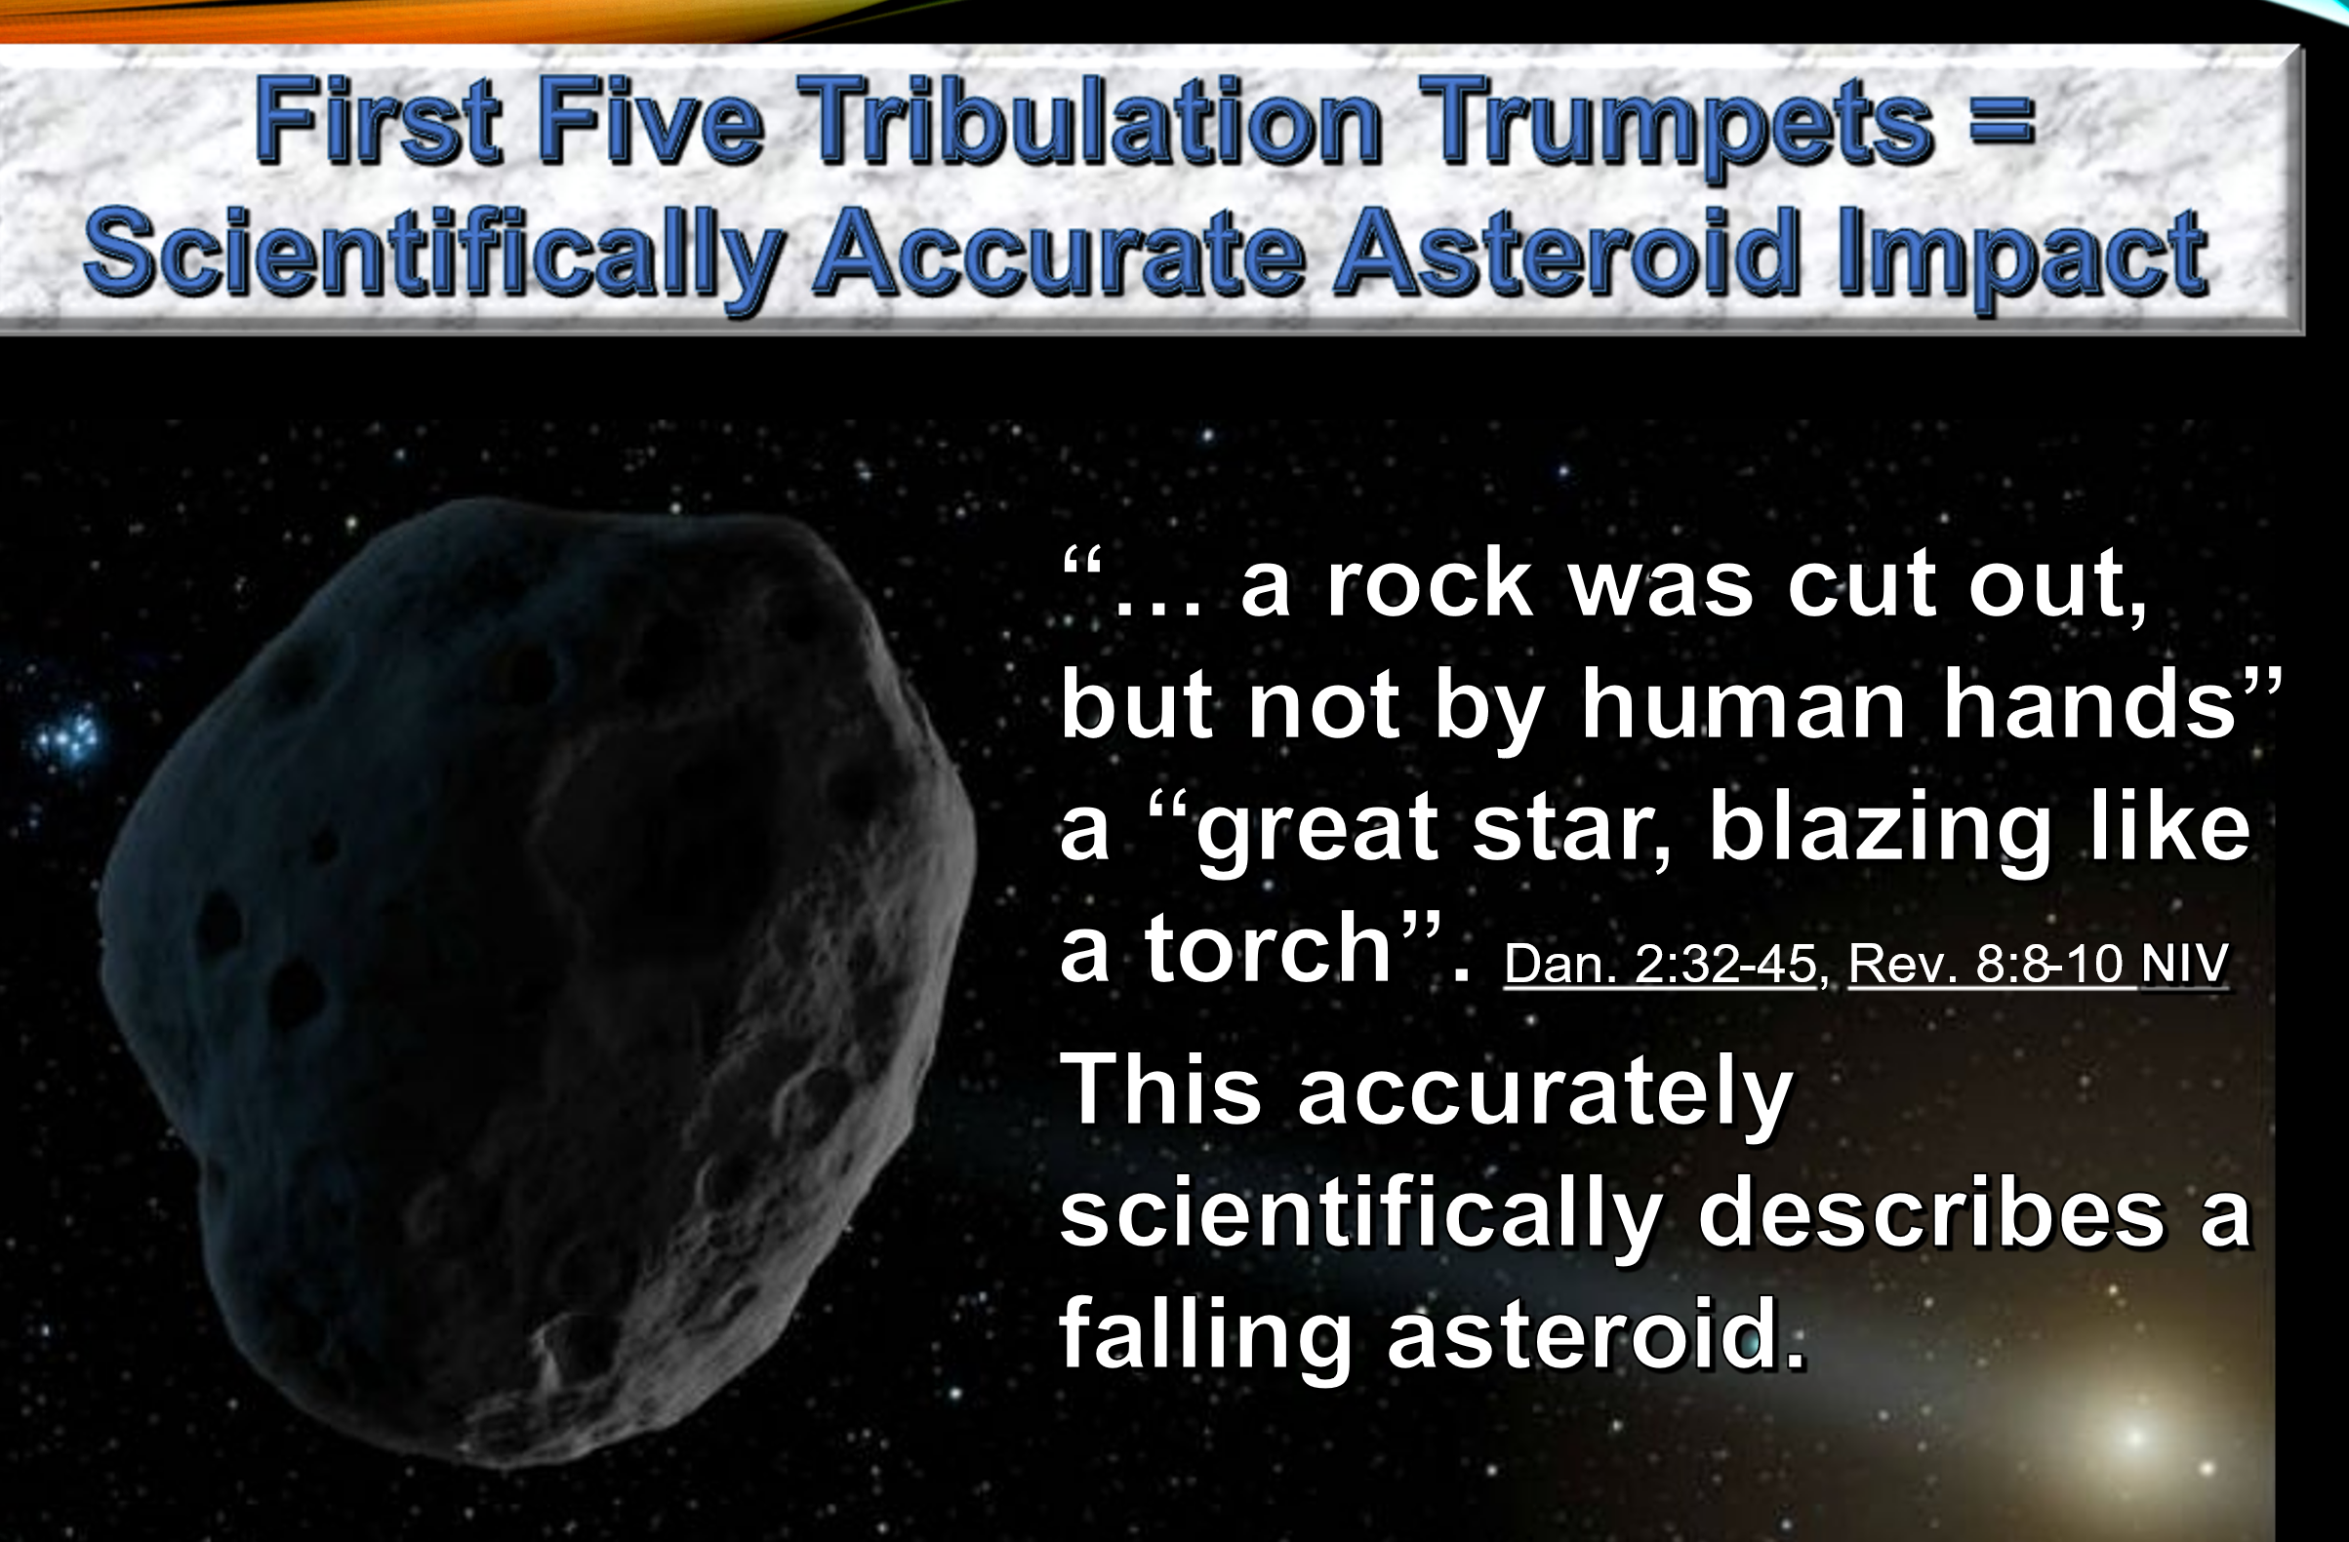
Video: Simulated Large Asteroid Impact with massive tsunami, worldwide fires and crater lake of fire, youtube.com/watch?v=yYgEwXWilUc
Over 50 large asteroids are confirmed to have struck Earth over its history. These large impacts also caused massive extinctions, volcanoes, fires, tsunami floods, earthquakes, and darkened the sunlight on Earth for many years, as the Bible described for the middle of 7 year end times. [847][849]
But Jesus gave instructions for Christians to escape the approaching end times. When Christians learn this information, their panic is replaced by joy. For Christians the end times are not the end, they are a glorious new beginning in an eternal Heaven.
We are to stand until Jesus returns and be joyful that His return is near. This book proves that if you don’t have Jesus as your savior, there will be no escape from the end times.
Jesus also instructed Christians in the Bible that they must leave their homes and not look back, similar to Lot when he left Sodom, but only when we hear the voice of the archangel, the trumpet of God and the shout of Jesus when the end times begin.
“It was the same in the days of Lot. People were eating and drinking, buying and selling, planting and building. But the day Lot left Sodom, fire and sulfur rained down from heaven and destroyed them all.
It will be just like this on the day the Son of Man is revealed. On that day no one who is on the housetop, with possessions inside, should go down to get them. Likewise, no one in the field should go back for anything. Remember Lot’s wife!” Luke 17:28-32 NIV
“… the kingdom of heaven be likened unto ten virgins, which took their lamps, and went forth to meet the bridegroom... But the wise took oil with their lamps… at midnight there was a cry made, Behold, the bridegroom cometh; go ye out to meet him… And while they went to buy, the bridegroom came; and they that were ready went in with him … the door was shut ” Mat. 25:1-12
“For the Lord himself will come down from heaven, with a loud command (shout KJV), with the voice of the archangel and with the trumpet call of God, and the dead in Christ will rise first.” I Thess. 4:16 NIV
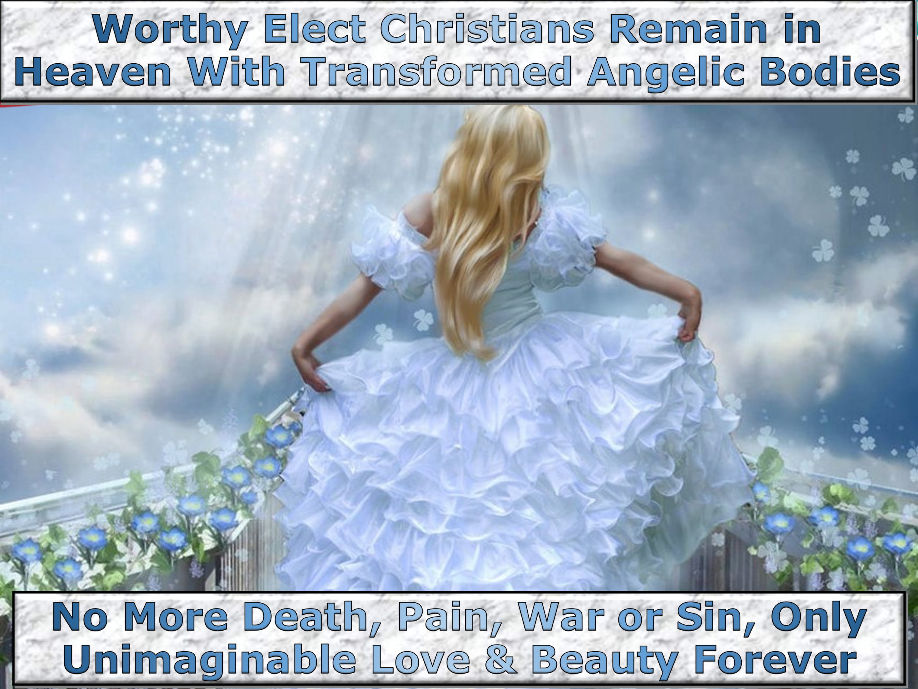
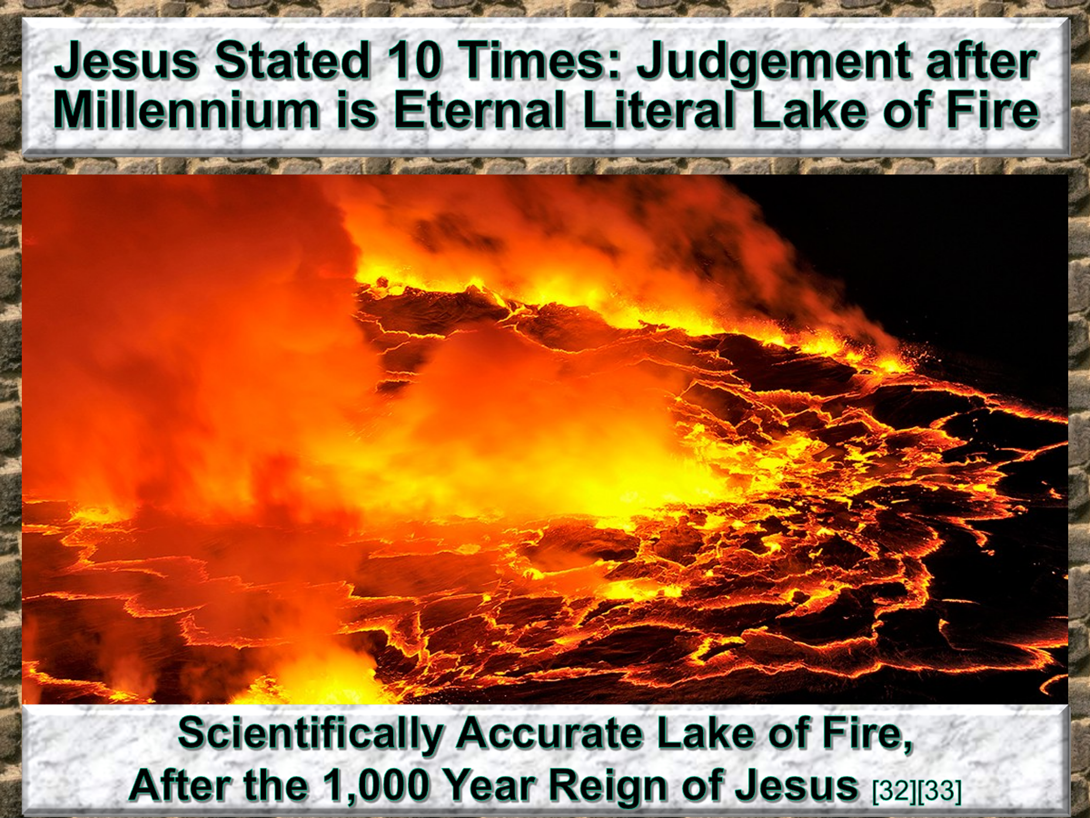
Evolution Is Not Science eBook free download at godrevealed.net
The literal Bible was more scientifically advanced than imagined! Einstein believed in God the creator and stated that time is an illusion. But thousands of years earlier the Bible said God could accelerate time, make time stand still and reverse time. (Is. 38:7-8, Josh. 10:10)
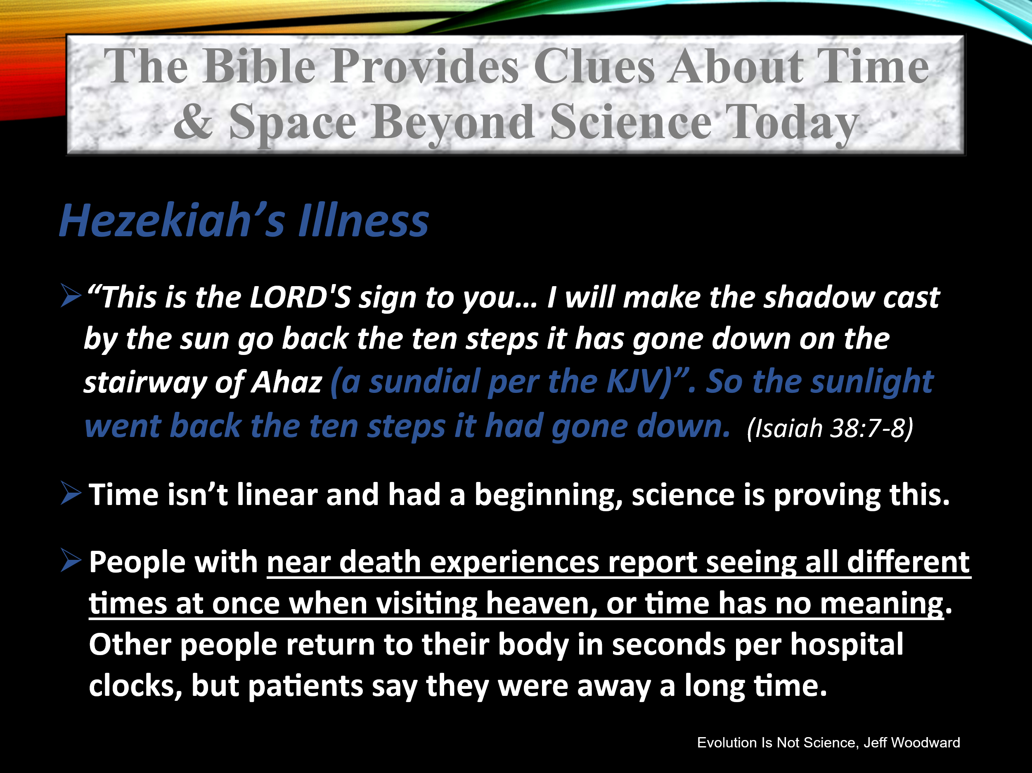
Videos - Einstein Stated that Time was an Illusion: youtube.com/watch?v=vrqmMoI0wks; youtube.com/watch?v=ZyYqyYAKGC0

God used incredibly advanced science to create the universe, young and old at the same time. God created the entire universe in seven consecutive twenty four hour literal days as the Bible stated. But in the time path God traveled, that doesn't equal the time path of the stationary rocks, as measured by our instruments.
The timeless wormhole path (”heavens opened”, “door was open in heaven” Acts 7:54-59, Rev. 4:1-2) that God traveled through during transcendent creation, determined the total time of 7 consecutive twenty four hour days that God experienced during creation. But both time paths, 7 days and 13.75 billion years, still exist simultaneously. Therefore, the universe is both young and old at the same time.
But there were no other conscious beings that experienced the full time path of 13.75 billion years of the universe during creation. This time path exists but is not valid to describe the age of the universe. Only God’s 7 day time path is valid, because He was the only conscious being that experienced time during creation.
This book corrects the intentionally misnamed Big Bang, that isn’t a random or accidental explosion. Instead, it is scientifically proven to be correctly named the intelligently controlled Big Expansion with unimaginable fine-tuning, that God literally described in the Bible. This unimaginable fine tuning is shown in the >200 proven Anthropic Principles.
God created our expanding universe, that began as an open folded fabric “curtain” (described scientifically as a folded space-time fabric), in a “tent" of stars (scientifically called our universe). God then closed this curtain to expand it to become a nearly flat fabric curtain, to form the scientifically proven nearly flat space-time fabric universe today. Matter precipitated out of the invisible kinetic energy released during this flattening and cooling, from the early higher energy folded fabric universe. (Journey Toward Creation, Hugh Ross) God stated that “what is seen was not made out of what was visible”. (Heb. 13:3 NIV)
The Big Expansion intentional creation by God of the universe is literally described in the Bible in Isaiah 40:22, 42:5.51:13, Jer. 10:12 & Zech. 12:1. It is one of the most rigorously tested and proven facts in science.

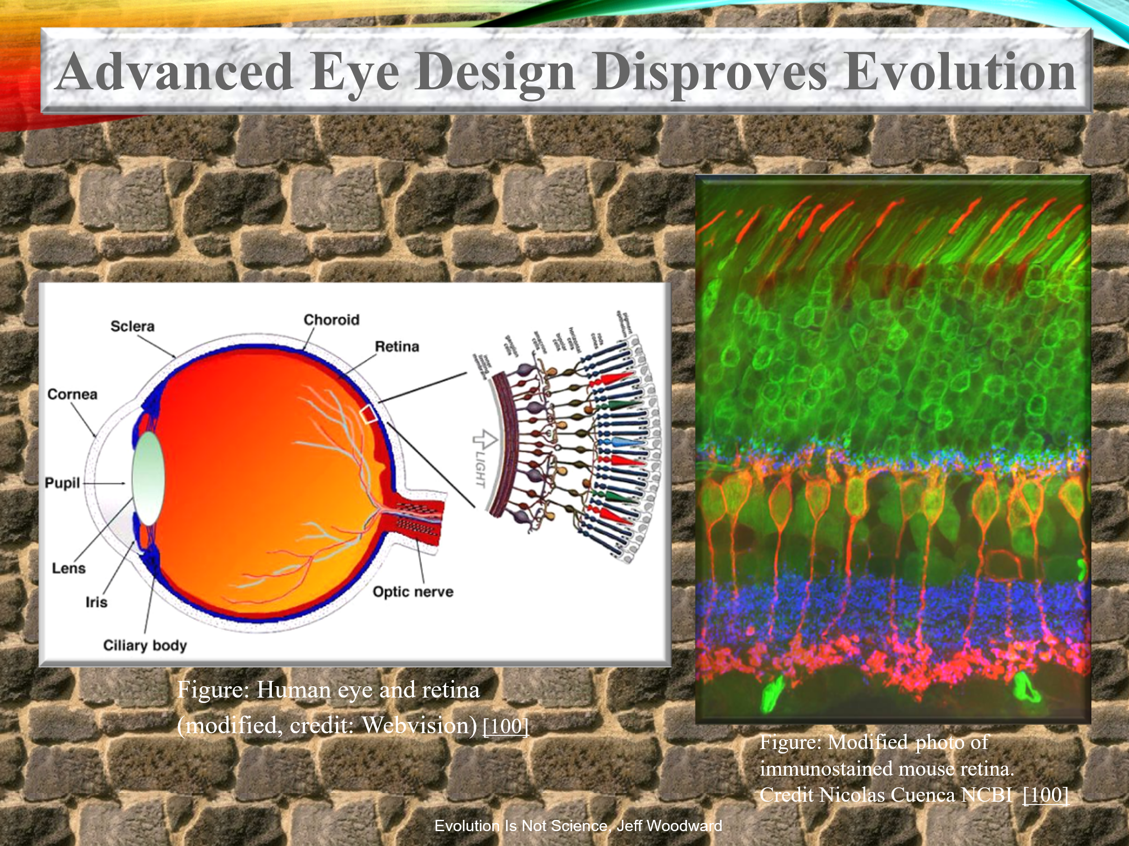


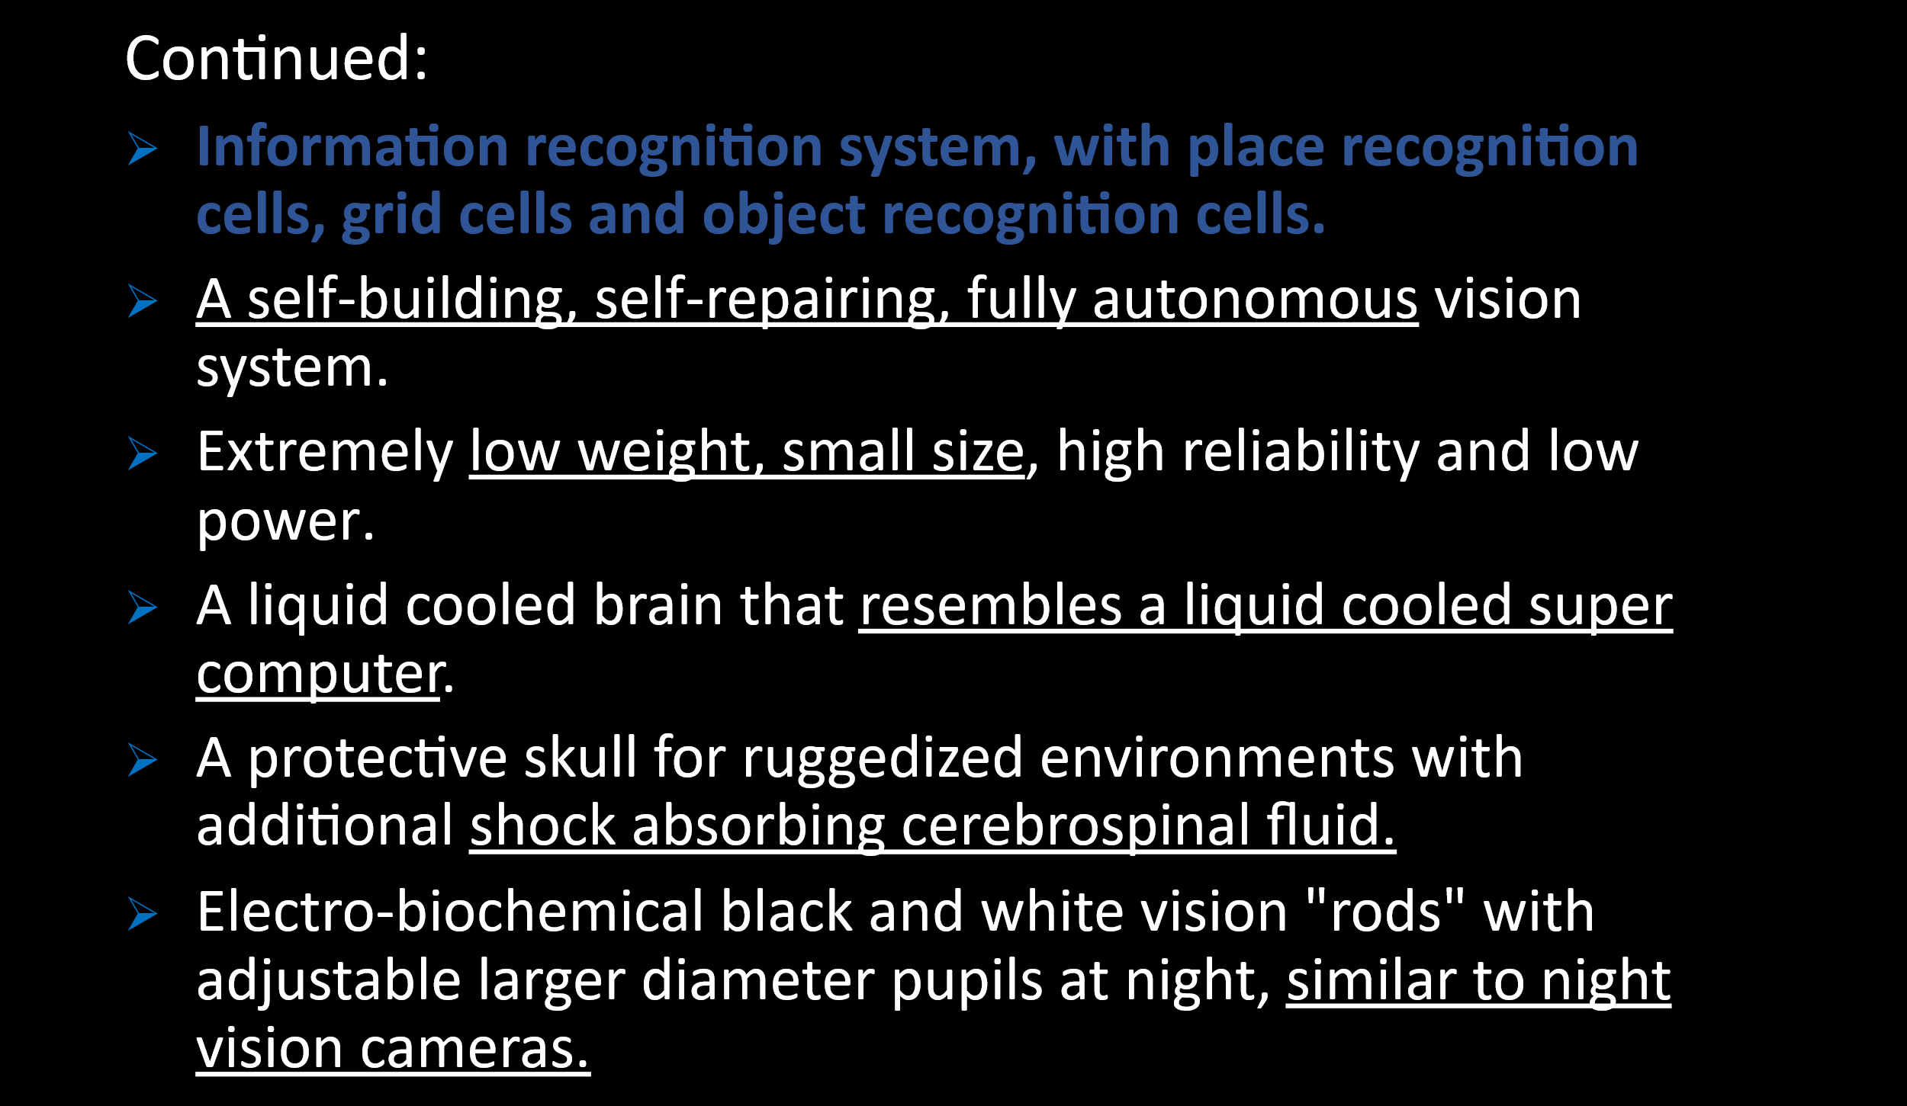
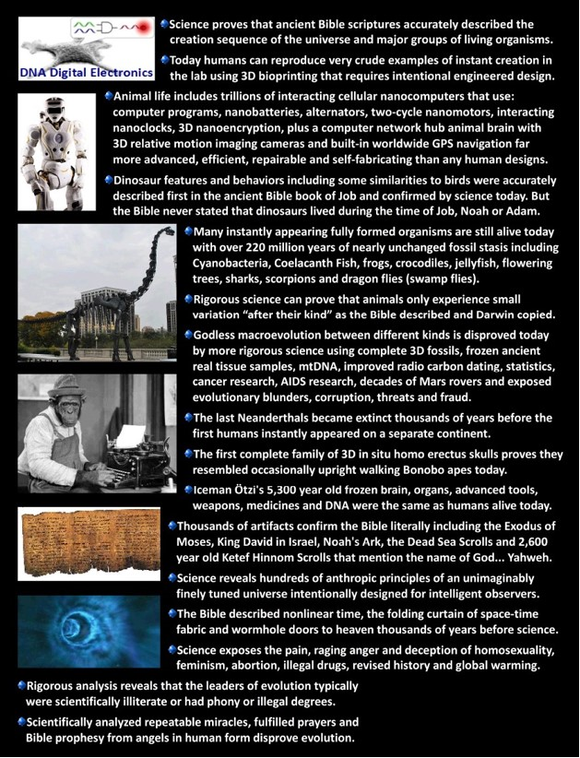
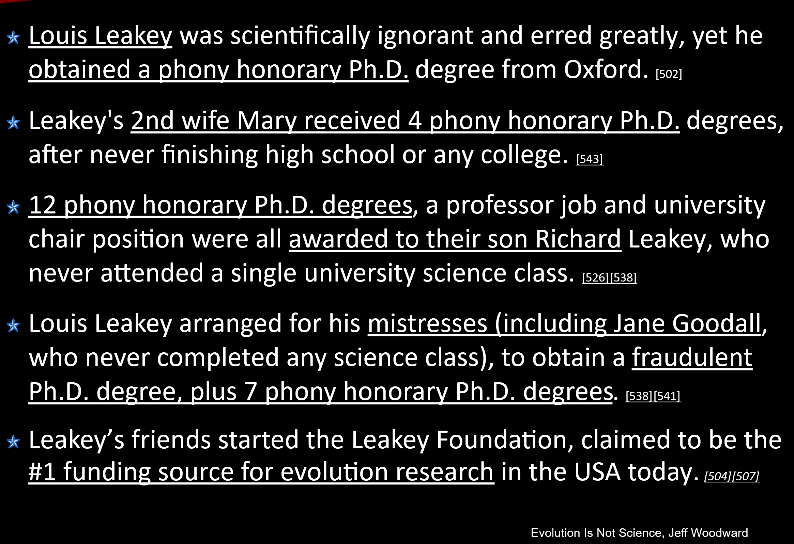
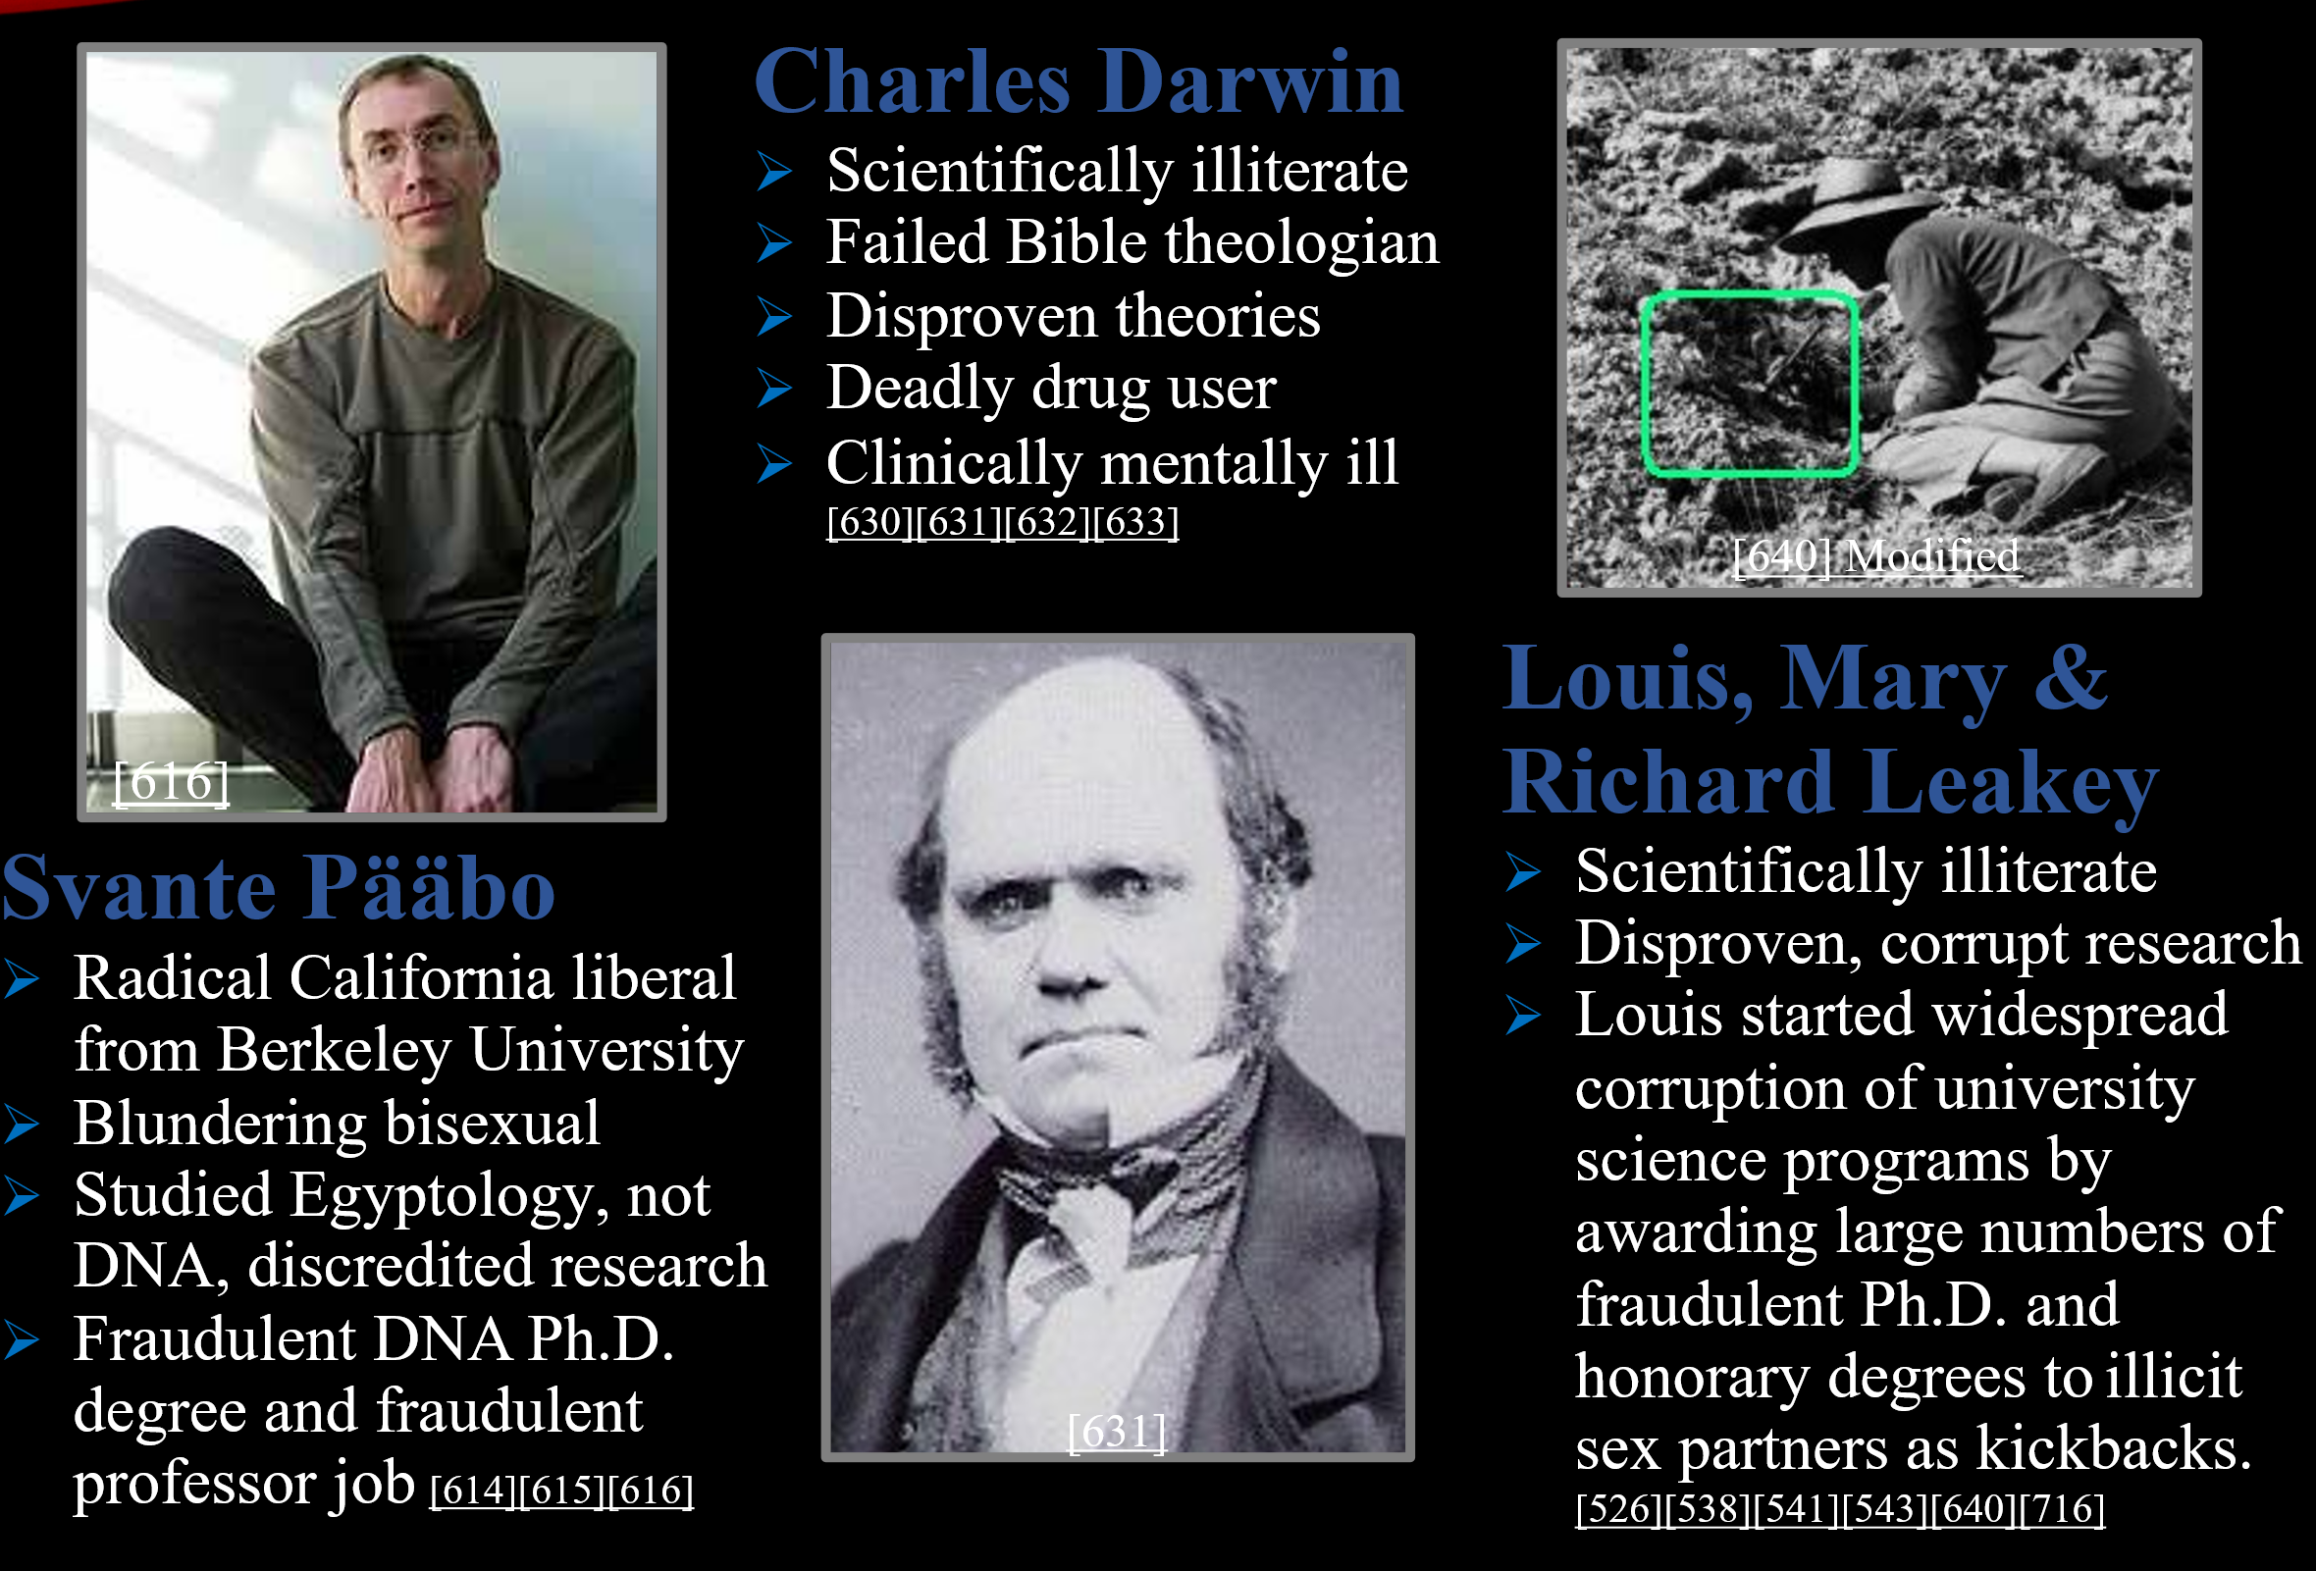
Guide to Noah’s Ark & Flood of Noah Discoveries: The Noah’s Ark discovery correlates to Bible descriptions 100%, including 300 cubit length (long Egyptian). The Noah’s Ark site is 518 foot (158m) in length, over half the size of the Titanic. It is broken in 2 pieces near the top of Mt. Ararat, buried 13-36 feet inside a frozen glacier, in an avalanche zone of constantly falling rocks that nearly killed a researcher. It is in a dangerous closed military zone between Turkey, Armenia and Iran, at a frozen altitude of 12,726 to 15,149 feet (3,900-4,700 m). Research reveals that Armenian & Kurd locals, including guides, for centuries covered up all entrances, intentionally guided explorers away from the Ark and lied to discredit the real Ark site: to preserve it, to fund Muslim terrorism & protect Armenian independence. But one Christian guide decided it was time to reveal this site to the world.
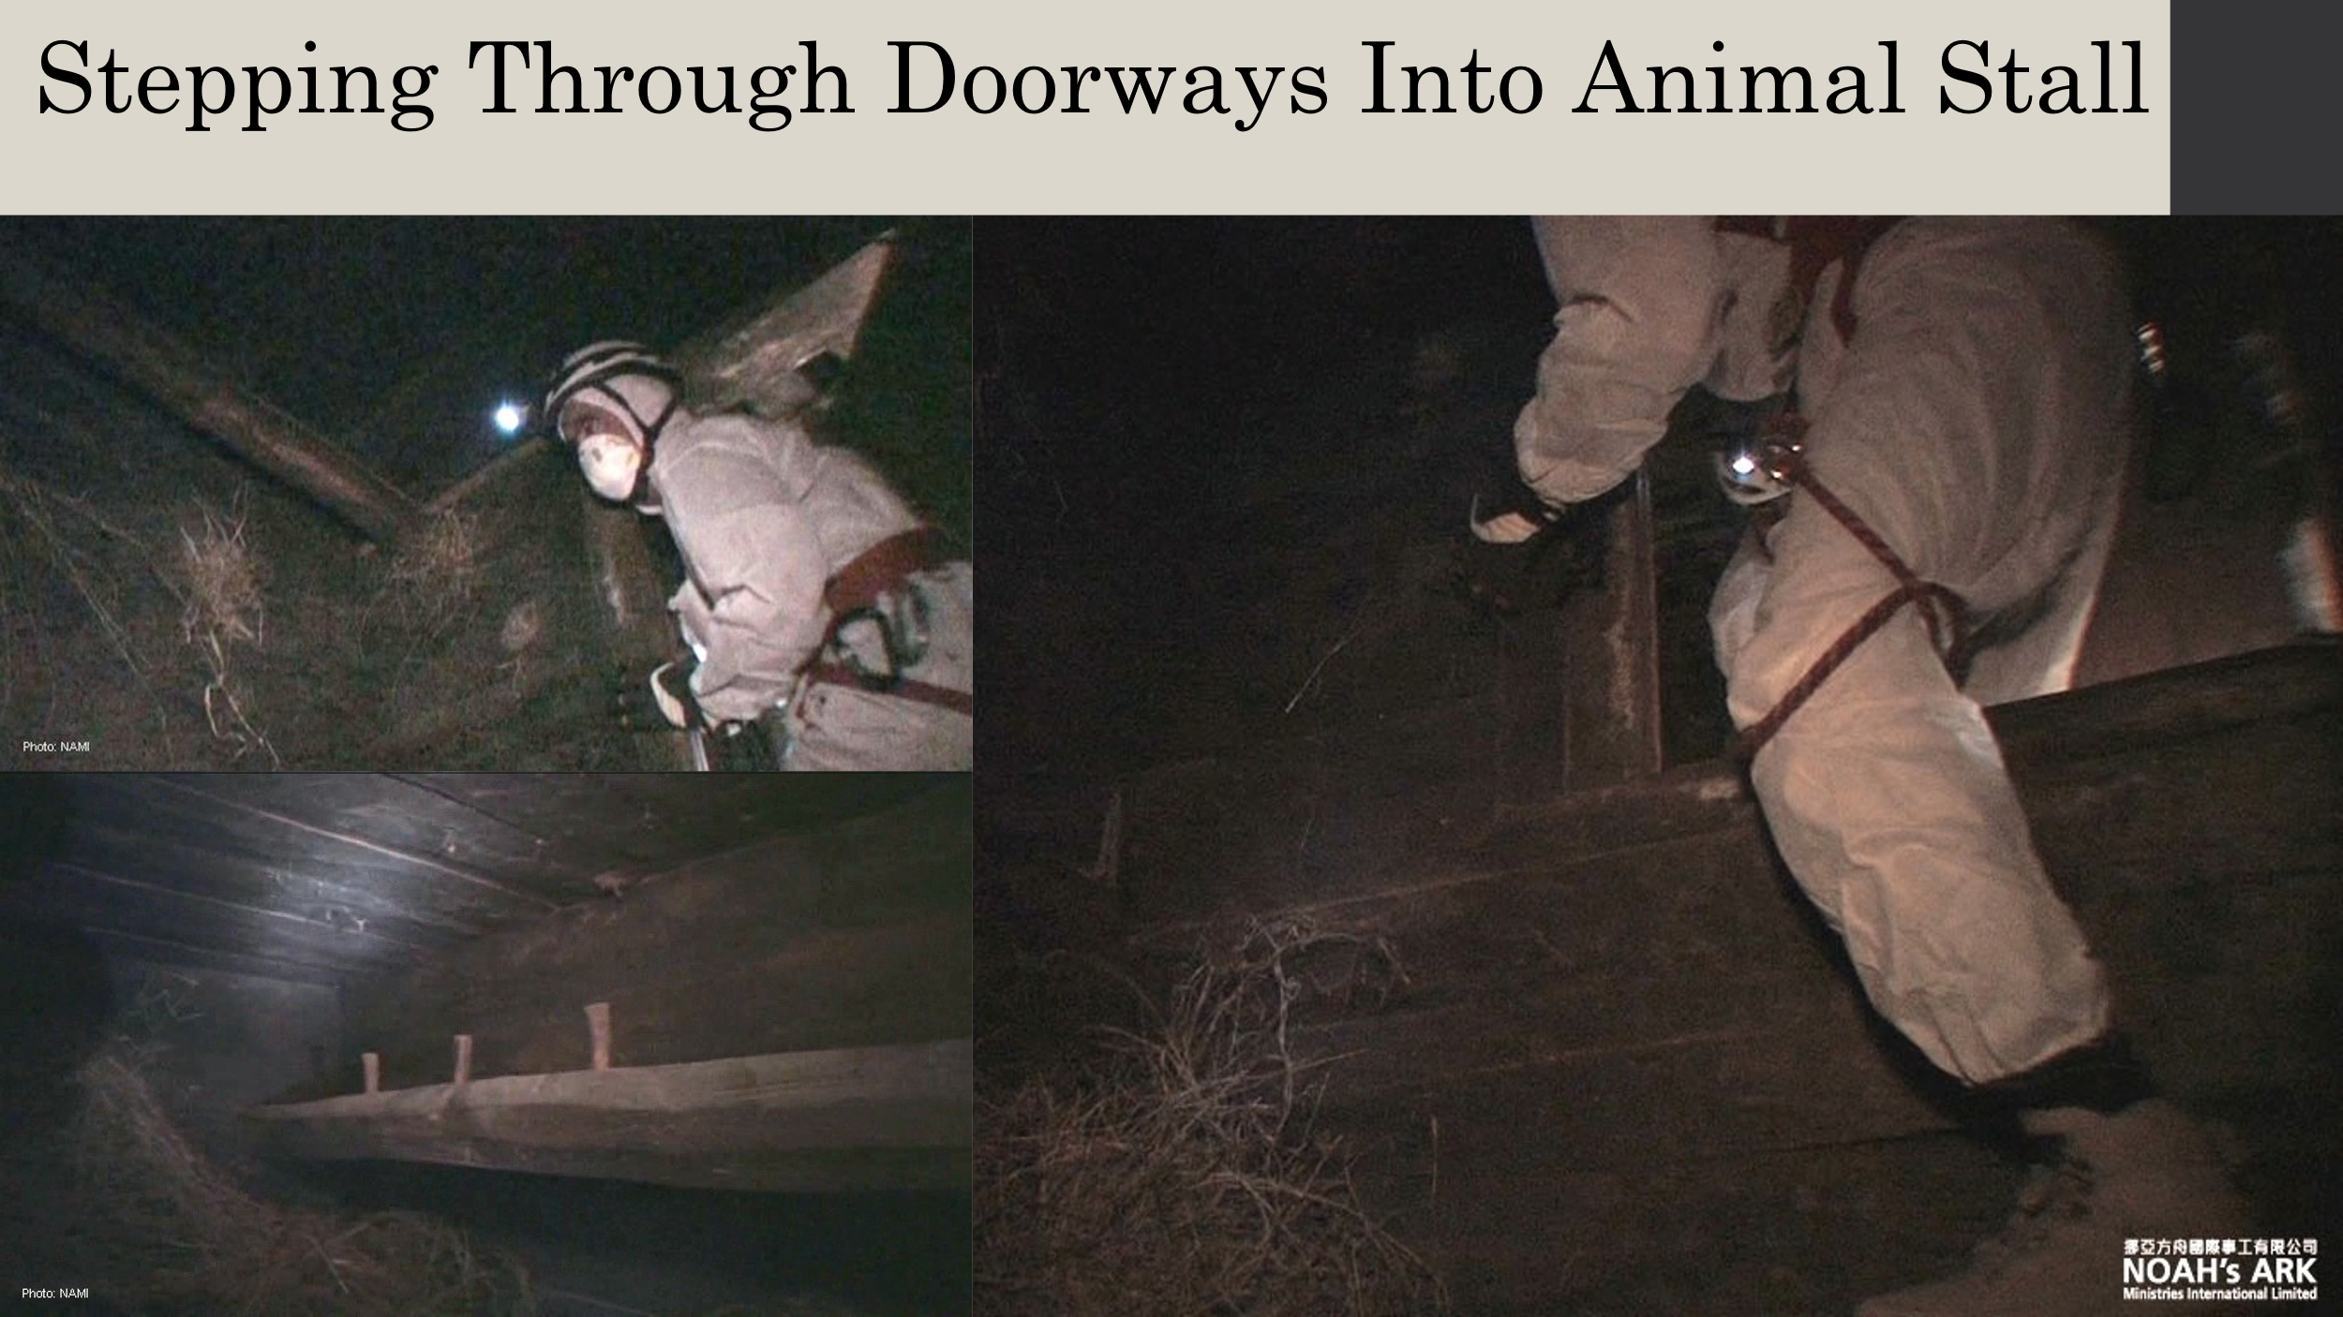
Joel Klenck joelklenck.com, a Harvard Ph.D. anthropologist in field of archaeology studied the Ark from 2011 - 2025. He now certifies and rigorously scientifically proves this is Noah’s Ark at the traditional Mt. Ararat site.
It contains complex advanced ancient ship building features including: utilitarian furniture all attached to the walls, a massive exterior hull made of rough hand hewn curved wood, wooden tenons and no nails, numerous large cross beams to the floors and to the middle of walls, evidence of severely stressed and aged seafaring cypress wood (gopher wood) that secrets sap when stressed (this is evidence of the ancient ship building techniques of slow steam heating to form each massive custom shaped curved wooden hull beam). Levant petroleum pitch & cypress pitch were used extensively on the Ark’s exterior & interior surfaces, plus on hand tools. It contains rows of huge rock ballasts for balance. This massive boat contains thousands of ancient artifacts that are now on public display in government endorsed museums in China & Turkey. (joelklenck.com)
Scientists found ancient late Epipaleolithic pottery (including extremely rare pre-ceramic pottery made of vegetable matter preserved by the ice), three wooden decks, log stairways, barnacles attached to the external hull, large ancient continuous sheets of undisturbed algae and bacteria covering many boards (that proved it wasn’t assembled on site), waste products & DNA from thousands of different kinds of early modern animals preserved by the ice. This includes thousands of pieces of melting feces and real tissue including: fur, feathers, scales, shed skins & exoskeletons, but no animal bones from animal deaths. Scientists also found thousands of modern animal footprints, but no dinosaur footprints, feces, claws, scales or cages of dinosaurs on Noah’s Ark.
Scientists discovered ancient animal food, plus chickpeas (that are highly nutritious, contain protein needed by meat eating animals & slow metabolism of animals to reduced food consumption on the Ark). (Philip Williams)
They discovered thousands of animal cages up to 13 feet long. But to date, have discovered no real dinosaur tissues or their huge feces on Noah’s Ark, as Young Earth Creationists erroneously claim. Noah’s Ark contains wood partially petrified by volcanic ash that covers the site. Extensive pottery and radiocarbon dating from the exterior and center of wood beams at different locations prove this is the authentic Noah’s Ark from the Late Epipaleolithic Period from 13,100BC to 9,600 BC. (joelklenck.com) This shows radiocarbon and standard chronology dating have errors, that must be resolved with 5,176 year ago biblical Flood of Noah.
Hidden in a secret wall compartment, behind Epipaleolithic pottery in the kitchen, scientists also discovered the world’s oldest book (codex), written in an ancient form of Paleo-Hebrew on a calf skin, with an exquisite gold dust picture of a camel on top Mt. Ararat. This book also has a second picture that shows Mt. Ararat and lists the exact number of animals on the Ark 39,035 & clean animals 7,112. This book also describes an animal sacrifice with an angel present after leaving the Ark and describes the worship of a single God. (joelklenck.com)

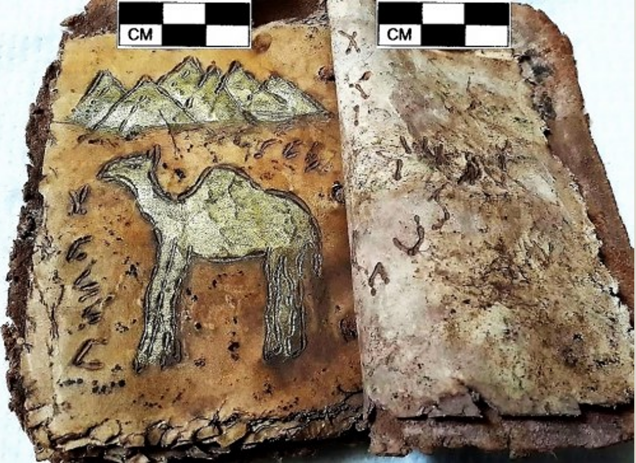

www.releasewire.com/press-releases/archaeologist-joel-klenck-reports-discovery-of-earliest-writing-noahs-ark-codex-in-archaeological-context-from-late-epipaleolithic-period-13100-and-9600-bc-1358897.htm
See discoveries over 15 years by international teams of scientists & past explorers at 5th International Symposium Of Mount Ararat & Noah's Ark Abstract 2019 and Noah’s Ark on Mount Ararat, Shortened Eyewitness Accounts.
Appendix E (titled “Noah’s Ark & Flood Geology Disproves Both Evolution & Young Earth Theory”, of the eBook “End Time Events, Heaven & Hell”) proves that past destruction of the world by Noah’s Flood caused a massive worldwide population decrease, at the same time as a massive worldwide geological discontinuity of all top young sedimentary and shale rock layers that are all missing worldwide.
This eBook proves these top layers of soft new shale and new sedimentary rock layers were slowly dissolved in this yearlong flood, then washed away as slumping mud and sand down rivers, to self-level on the ocean floor. The ocean floor due to mud “slumping” (self-leveling) is the flattest place on earth, with mile deep mud.
This theory appears to be confirmed by Noah’s family in the Ark Codex book that mentions that as the flood water receded, it resembled a ”kneading trough” (of thick watery mud that) “runs down”. (joelklenck.com)
This extensive erosion of the top layers from Noah’s Flood is also shown in the book “The Archeological Evidence of Noah’s Flood” (Philip Williams, 2011, pg. 138-139, 144-150), that includes Dame Kenyon’s Jericho site research that shows “extensive … severe erosion occurring throughout Palestine (ancient Israel)” and Kathlyn Kenyon’s sketch that shows thick layers of deposited “water laid fine silt”, plus severe erosion at the same time, between ancient rubble layers of pre-flood Early Bronze and post-flood Middle Bronze Age Jericho.
This erosion at higher elevations and partial water laid fine silt in only lower areas is found worldwide at the end of all Early Bronze Age cities, including Ur. Higher elevation structures are exposed, with little or no silt.
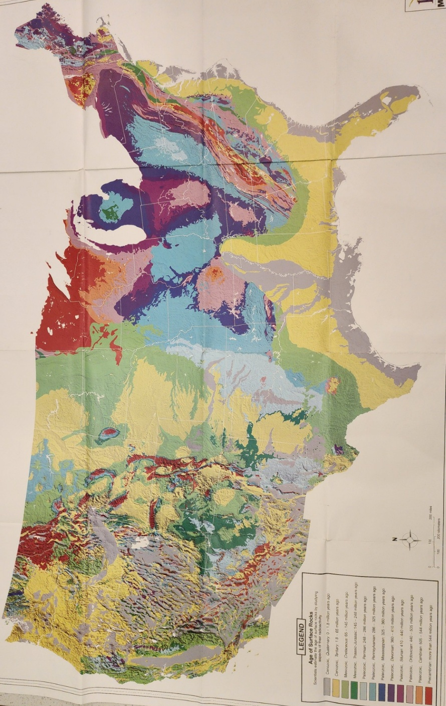
The ancient age of the US surface rocks in the map show this worldwide surface rock discontinuity. All the elevated regions have young surface rock layers that are missing. Many regions of the US have no new surface rock layers built up over the last ¼ billion years of geological activity. Consecutive lower levels of the geological column, with a few small rock layer discontinuities that only exist over a small local area, shows that a massive worldwide surface rock layer discontinuity is impossible, through past natural processes alone.
(Credit: K12 Maps.com)
This discontinuity includes the Southern US, where there were no ice age glaciers that could have caused this drastic erosion. This discontinuity is also seen in extremely dry Arizona desert mountains, where rain is rare.
The slumping thick flowing mud was rapidly dissolved from sandstone rock at higher elevations under this yearlong Flood of Noah. This flood water also allowed the formation of massive flat layers of new gray colored sand & mud in the map at all lower elevations. This made the Western US have uniform extremely flat land, between the jagged Rocky Mountain peaks, over the entire rocky mountain range, including high elevation Utah and the flat Central Valley of California farmland. This self-leveling mud created flat land over much of the world at the same time that is geologically impossible without a massive worldwide flood. Noah’s 1 year flood leveled the land over most of the US making it livable, fertile and farmable for humans today, by design.
The Flood of Noah is also proven by similar burial mounds or tels that exist worldwide that were extensively researched by Philip Williams. For example, at Tel Megiddo in Israel and the cliff dwelling in Mesa Verde Colorado, the bottom oldest layer was excavated and contained victims trapped by the Flood of Noah. Each mound, city or tel worldwide contains bodies entombed in their intact homes, businesses, palaces or cities, with all their possessions, wealth, weapons, babies and healthy young people. At the ancient city of Ur, they were partying at a drunken festival with dancing girls, when the flood waters suddenly flooded their buildings and drowned them all.
Early Bronze age sites in Great Britain, including Stonehenge, are the foundation stones for a multi-floor palace at the center of the city. The decomposed wooden worker houses surrounded this palace in a large circle. (Phillip Williams “The Archeological Evidence of Noah’s Flood”
The skeletons of all these people are slightly bent forward at the waist, with arms & legs stretched out slightly in front of them & upward due to floating in floodwater in their homes. Bodies in this position are found in drownings. Their skeletal remains were preserved because they were trapped inside thick walled Early Bronze buildings. Peaceful and very different looking people later lived in the same area & buried their dead on top of the same mounds or built cities on top. A few bodies were mummified with skin & clothes preserved (“Ancient Light from this Mountain, pg. 8-17), (“The Archeological Evidence of Noah’s Flood” 2011, pg. 88-103, 138 – 195).
All preserved buildings on the bottom oldest layer of these worldwide pre-flood mounds, tels, cities, Sphinx, Stonehenge, etc. are built on the same surface bedrock layer as today. This shows that when the flood occurred, no new fossil rock layers were added on top of these preserved pre-flood homes, people & artifacts.
They are all found on the same bedrock surface layer as today. We have thousands of deep mines and deep drilled wells worldwide with core samples. Yet none of these discovered any evidence of pre-flood human homes, metal artifacts or human remains under the >1 mile deep geological rock layers, as Young Earth Creationist theories demand, because they believe all geological layers & fossils formed during flood of Noah.
Noah’s Ark contains large rocks for ship ballast made from sedimentary rocks, plus rocks that contain ancient seashell fossils from before Noah’s Flood. (joelklenck.com) These ancient geological rock layers and fossils on Noah’s Ark shatter Young Earth belief that Noah’s Flood made all the world’s fossils & geological rock layers.
Furthermore, far beneath the top bedrock and glacier layer that contains Noah’s Ark on top of Mt. Ararat, there are deep sedimentary rock layers, plus deep rock layers with only Trilobite fossils inside this mountain. This proves that Mt. Ararat was formed on dry land long before Noah’s Flood, humans or dinosaurs. This disproves Young Earth Creationist claims that Mount Ararat was formed in only 1 year from all the continents moving around rapidly under the flood water, to form all continents, all mountains and all geology worldwide.
Noah’s Ark on Mt. Ararat disproves both the satanic science of evolution, plus disproves the unbiblical simple linear time Young Earth Creation, with dinosaurs on Noah’s Ark and all geology formed from Noah’s Flood.
The 5,300 year old preserved soft tissue of glacier frozen pre-flood Sicilian human named Iceman Otzi and real bones of 10,000 year old pre-flood Asian human Le Brea Women discovered in the Tar Pits of California were each found on the same surface bedrock layer as today. These humans didn’t become rock fossils with many new rock layers formed on top, as Young Earth Creationists erroneously propose from Noah’s Flood.
The 38,ooo year old Le Brea Tar Pits are a time capsule containing entire ecosystems with millions of animal bones and 1 million real soft tissue preserved animals, plants & insects. This includes mammoths & thousands of saber-toothed tigers (a-z-animals.com, Meet the Holy Grail of Ice Age Fossils). But these tar pits don’t contain any real tissue or fossils of dinosaurs or any creature from the older dinosaur era. Frozen glaciers also contain preserved real tissue of modern mammals, including entire mammoths, but no frozen real tissue of dinosaurs.
Recent dinosaur soft tissue discoveries are only rock fossils of the dinosaur soft tissues, not the original real soft tissues. But a few tiny, rare cases of real dinosaur soft tissue were claimed to be found in the center of a horn or skull rock fossil. This tissue was slowly smoked, charred and preserved like beef jerky near a fire. This charring altered, toughened and cross linked this ancient soft tissue, as it was entombed and sealed in the oxygen free protective center of the dinosaur horn or skull. Later the rest of the horn or skull turned to rock.
Young Earth Creationists can’t explain the fossil record that shows the same creatures at only certain rock layers that are predictable and consistent worldwide. They can’t explain 50 large meteor impacts, repeating ice ages or reversal cycles of Earth’s magnetic field that are frozen in rocks forming a clock. They can’t explain repeated consecutive island formation by plate movement over hot spot volcanos at constant rates.
They can’t explain the speed of light, frame dragging over time of space fabric around large rotating planets in space, gravity waves or Cosmic Background Radiation that allow us to see far back in time, and prove space time relativity, where time slows down & stops, as we can prove by clocks on satellites that slow down.
They can’t explain why tree ring dendrochronology of consecutive tree rings date back 13,910 years, before the claimed 7,000 year total age of the universe. As of 2023, securely dated tree-ring data for Germany, Bohemia and Ireland are available going back 13,910 years. A new method is based on measuring variations in oxygen isotopes in each ring, and this 'isotope dendrochronology' can yield results on samples which are not suitable for traditional dendrochronology due to too few or too similar rings. [1316]
They can’t explain why the recent Noah’s Ark discovery disproves all Young Earth Creation theories. Young Earth Creationists can’t explain why all their coal samples have radio-carbon dates of 20,000-80,000 years old as measured by Young Earth scientists, older than the claimed 7,000 year total age of the universe.
The Flood of Noah also could not deposit in one flood, lasting only one year, five repeating thick minable layers of coal on top of one another 1,000 feet deep, in several US Midwest states. [952] (pgs. 16-17) Furthermore, each of these coal layers are also separated by the same repeating sequence of completely different thick rock layers, that can include thick layers of ancient sun evaporated salt, located below coal layers. [952] (pgs. 16-17, 71)
“This cycle (of entire rock layer sequences repeating), which is characteristic of late Carboniferous coal-forming environments, was repeated some 14 times, depositing more than 900 m (2,700 ft.) of ‘coal measure’ strata and 45 separate coal seams over the course of about a million years (linear human time). Studies have linked this pattern of periodic deposits (of rock layer sequences repeating), to the development of an ice age, with a cycle of alternating cool ‘glacial’ and warmer ‘interglacial’ climates”. [951] (Ch. 47 2nd pg.)
One salt layer forms as the Sun evaporates a large shallow body of stagnant salty water. Yet, several salt layers are found under many repeating coal layers. Some salt layers are over 1 mile deep. [952] (pgs. 16-17, 71)
These thick, deep sea salt layers, with fossils of ancient extinct animals, plus trapped sealed oxygen bubbles and water drops, with oxygen and salt levels radically different than today, proves that the repeating evaporation cycles of large bodies of water existed long before the recent Flood of Noah. The air bubbles in this ancient salt layer contain only 10.9% oxygen. This low oxygen atmosphere couldn’t support human life, including Noah’s family. Humans require 19.5 to 23.5% oxygen to survive. [971] [972]
Young Earth claims that no death had occurred before sin in the Garden of Eden are also not biblical or scientific. The Bible only says that death came to mankind (not animals or plants) after sin. The Bible said that Adam & Eve ate plants that died in the Garden of Eden, before they sinned. Plants “die” per Jonah 4:10 NIV.
Young Earth Creationists use an equation to calculate the age of the universe that adds up the genealogies in the Bible, plus adds 7 days to arrive at an unbiblical 6,717 year age of the universe. The problem is that the Bible NEVER stated to calculate the age of the universe by using this equation, to add up genealogies.
The Bible simply gives the genealogies and lists the 7 days of creation, those are both correct individually. But we can’t add them to create an unbiblical age of the universe equation, that is NEVER specified by the Bible. This is because time was more complex than we imagined and scientifically proven to be an illusion. But this was literally described in the Bible thousands of years before science discovered it.
Young Earth Creationists illogically reject all rigorously proven science that agrees with the Bible. They illegally change Bible verses to match their predetermined outcome, then persecute other Christian scientists who seek the truth. They then claim we must throw out all rigorously proven science, because it doesn't agree with their unbiblical beliefs. The poor science of Young Earth Creationists has pushed tens of millions of Christians away from Christianity into atheism, evolution, homosexuality and the occult. This includes Charles Darwin who abandoned his original belief in God’s creation and studies to become clergy. Young Earth Creation was invented by Catholic Archbishop Ussher and other churches that change the Bible.
However, the revolutionary new creation theory I present DOES follow all rigorously proven science, MATCHES every Bible verse literally and DISPROVES all evolutionary junk science. This new theory is Transcendent Creation (TC) by God. God lives outside of time and uses dimensional wormhole doorways as described literally in the Bible and proven by science today, in a universe that is both young and old at the same time. Time can accelerate or stop as proven by science and stated in the Bible thousands of years ago. God can pass through doorways in time to a timeless Heaven, because time is an illusion.
Evolution Is Not Science & Jesus Heals Gays & Transgenders both expose the true world history of socialism, racism & slavery that liberals today desperately try to hide. Multi-culturalism is not the solution and is not required for salvation. My multi-cultural wife taught in one of the most multi-cultural US liberal inner city schools. After the 7th year of Obama’s disastrous presidency, 1/3 of the school’s female students and people walking down the city sidewalks now wore Muslim head scarves or full body covering black burkas, with eye slits. They were recent Muslim illegal immigrants from Muslim war torn nations. Their air flight to the US, plus for 6 months, all their food, rent, phones & living expenses were paid for by the Muslim Obama administration.
But there was no tolerance for other cultures or peace. It was a literal war zone, run by liberal democrats. Every culture hated each other. Violence, molestation, mental illness, rape drugs and murder were common. This was the African American replacement in the inner city… by violent Black Muslim new immigrants. I witnessed this personally for 5 years. Other Christian or conservative immigrants were blocked & not allowed to immigrate. The illegal immigration invasion devastated the city and was repeated in the Biden presidency.
President Trump confirmed the 10 most murderous cities in the US were all run by democrat mayors. [1280] (video - Republican National Convention 2024), [1279] (2020) All but one of these murder filled liberal cities were run continuously by liberal democrat mayors the last 30 to 140 years. [1279] (2020) & (Wikipedia list of mayors)
School statistics today also confirm rape or sexual molestation of a shocking 70% of all elementary school children by other students at school, friends or by family members at home. This extreme constant violence together with the perversions and trauma witnessed daily on tv and movies caused nearly all teachers and students to develop mental illnesses, including PTSD and attention deficit disorder.
Gay criminal Marxists and radical Muslim terrorists, tried to overthrow the US in the bloody 2014 to 2020 nationwide BLM & Muslim Antifa riots, where they assassinated, defunded & ambushed police. They murdered Christians & tried to install Sharia Law in US inner cities. [571] [572] [573] [1272] (38:30, 1:16:30) [1274]
Muslim Sharia Law enslaves women, legalizes looting, murder, polygamy, rape and requires all females to have all 3 genitals mutilated. [572] [573] [1205] [1239] [1240] [1241] [1243] [1272] (38:30, 1:16:30) My family personally heard the testimony of a young US schoolgirl at her downtown school. She painfully experienced Muslim genital mutilation by her family, when sent to visit them in her native Middle Eastern Muslim country.
Another immigrant, Isak Abla planned to be a suicide bomber against Israel. She grew up in Turkey during their Civil War. She regularly saw bombs exploding and machine guns used in the streets. She was repeatedly raped and violently beaten as a Muslim wife, by her Muslim husband and developed PTSD.
She says there is no love in the Muslim religion. [1272] (38:30, 1:16:30) Murder, rape, slavery, injustice, lying and racism is legal and encouraged. Suicide bombers have streets named after them and receive large cash rewards. [522] [561] [562] [566] [746] She never had joy or laughed. Muslim women who laugh are prostitutes.
She later came to the US and was raped and abused further by Muslim men. She wanted to commit suicide. But loving Christians evangelized and ministered to her. She was hungry for the truth and saw miracles. She became a Christian and says she was released from many demons. She later became a leading US Christian evangelist of love, who has peace, joy & heals people through Jesus. sidroth.org/television/tv-archives/isik-abla/
Today many Muslims are learning the truth, that Muslims were enslaved, oppressed, murdered and tortured by their own Muslim leaders and families throughout history. But Jews and Christians tried to save them.
Muslims are realizing that foreign Muslim leaders long ago conquered their lands with the sword and forced all their people into this evil Muslim religion. They were killed or raped if they refused. Then these Muslims were indoctrinated all their lives, from every media source and all schooling, to fight endless wars and live with no freedom. Ex-Shia Muslim reveals millions leaving Islam in Iran, youtube.com/watch?v=ShA-bWaW3LU


In the US 2020 Riots, gay, transgender & Muslim socialist Black Lives Matter terrorists: chant “f*** White people”, “Death to America”, burn Bibles and churches, murder and beat thousands of Whites only for their skin color, including children and the elderly.
twitter.com/i/status/1302741208570236935
twitter.com/i/status/1299936239680983041
twitter.com/i/status/1299354720998490116
twitter.com/i/status/1302380735425400833
twitter.com/i/status/1302786369643843585

The Maafa 21 video exposes suppressed Black history & verifies interconnected roots of democrat slavery, racism, eugenics, socialist Marxist Nazis, evolution & abortion. www.youtube.com/watch?v=ZAF2GPT_79Q I love African Americans; I want the truth to save them and set them free from this modern slavery to every vile sin.
Black on Black violence, looting and city burning in the US today isn’t new. It is a repeating demonic cycle over the last 1,100 years, from ancient Black African cities that Black’s also looted and burned regularly. These repeating mass murders and city burning riots were often started by Muslim immigrants, who immigrated into ancient Black Africa and pretended to be the friends of Blacks [573] [1278], the same as they do in the US today.
The first White men to explore the interior of 1800’s Black Africa were Christian abolitionist missionaries Dr. Livingstone and Mackay of Uganda (The Missionary Engineer). [1275] [1276] [1277] [1278] [1281]
They extensively documented the same horrific Black on Black rampant heinous murder, plus rampant Black on Black slavery by EVERY Black king in ancient Black Africa, who became rich by enslaving their Black tribal neighbors and selling them to Black Muslim slave traders. [1275] [1276] [1277] [1278] [1281]
They extensively documented the evil Black kings’ endless Black on Black civil wars, riots, abortion, witchcraft & human burnings over decades, before any other Whites entered Central Africa. [1275] [1276] [1277] [1278] [1281]
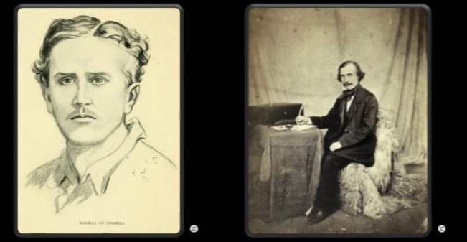
For centuries, from the 900’s to 1833, it was Black Muslim slave trader immigrants including Tippu Tip and his Sultan of Zanzibar Africa who paid the kings of the Black tribes in Africa to sell their Black enslaved “brothers” to Muslim nations. Livingstone dedicated his life to stopping this slave trade in Africa. He documented that the Black tribes repeatedly attacked their Black “brothers” in neighboring tribes and butchered them.
Two of my personal heroes: David Livingstone (right, credit: Wellcome Library, London) [1275] [1281] and Alexander Mackay of Uganda (left [1278] credit of Uganda [1278] & Mary Yule), voluntarily suffered nearly every imaginable hardship, disease, trauma, persecution, poverty and death, over decades in Central Africa, to help end slavery in Africa.
The Black tribal kings then sold those Blacks remaining, that they didn’t slaughter, to the Muslim slave traders who marched them with heavy loads of ivory, 500 miles to the seaports. The slaves who didn’t continue to march were speared and left to die and be eaten by the hyenas and vultures. The Muslim slave traders often had rape trees for the Black ladies and often lynched the Black men and women.
Then the liberal Whites and Muslims bought these slaves at the African seaports, to send on ships to different continents. [1275] [1281] Muslims and liberals sold their Black slaves around the world, including millions to liberals in England, southern Confederate Democrat slave states & the Caribbean (formerly called West Indies).
Christian missionary Mackay peacefully worked like a slave voluntarily in Africa for decades to help the Blacks of Uganda. He taught them skills, including work ethic and modern technology, to free them from reliance on the wealth from selling slaves. But the violent Black king of Uganda didn’t listen. He arrogantly said that he didn’t do physical work. Physical work was beneath him and was the job of his Black slaves. This Black king persecuted Christian missionary Mackay, who was nearly burned alive in one riot when the king died.
Later in other riots, immigrant Black Muslim slave traders falsely accused Mackay of trying to take over Uganda. As a result, Mackay’s first peaceful Christian followers were all burned alive. [1278] These Black riots in Africa were Satan’s work then, the same as murderous Black riots, looting and burning cities in the US today.
David Livingstone commented that near the end of the Black slavery era, sections of Africa became nearly empty of Black people. [1275] [1281] The immigrant black Muslims then took control of the former Black tribal lands and their wealth in Africa, all while pretending to save the Blacks from these peaceful White evangelists.
After decades of persecution and suffering, conservative Christian leader William Wilberforce and missionary David Livingstone helped to finally end the satanic worldwide slave trade, in the 1833 Slavery Abolition Act in Great Britain. The liberals in Great Britain had fought for decades to keep this slave trade legal, that made them rich. But a month after David Livingstone’s death in 1871, Britain finally threatened a naval blockade of Zanzibar that forced the Sultan to close the Muslim slave markets. [1275] [1276] [1277] [1278] [1281] [1284]
Muslim immigrants in ancient Africa deceived the Black African kings, by stirring up false rumors of civil wars and false White plots to overthrow Black cities and kill all Black people. [573] But in the end, it was the Black Muslims who conquered most of ancient tribal Black Africa… exactly what they accused others of. [1278]
We see this deadly pattern repeating again today in the US with rampant African American fatherless homes, Black abortion, Black on Black murder, Black homosexuality, raging anger, mental illness and Black gangs that have decimated Black families and communities. Today traditional African American communities are in rapid decline and being replaced by Muslim and Marxist immigrants by liberal politicians they blindly vote for.
African Americans today must wake up or the same dire fate will occur in the US today as in 1800’s Africa. We see semi-Black gay Muslims & Marxists including Barak Hussain Obama & Kamala Harris (both whose ancestors were slave owners as admitted by family members), whispering in the ears of African American leaders today about the same fake plots against Blacks by White Christians, as they did in ancient Africa. The result is that Muslims & Marxists are replacing all the African Americans in US cities, the same as they did in 1800’s Africa.
But today many African Americans are learning the truth, that conservative Christians have given their lives to free slaves throughout history, including hundreds of thousands in the Civil War. African Americans are also waking up today to realize that it was the liberal Democrats, the Muslims, plus communist & socialist Marxists who nearly drove African Americans into self-extinction by their own hands. Brandon Tatum: Damani Felder just destroyed the entire democratic party in 2 minutes https://t.co/ipBuBb3vF5" / X
Liberal Whites didn’t enter central Africa to capture the Black slaves. They would be killed by the fierce black warriors, deadly animals and diseases including malaria. Instead, it was the Blacks from every tribe, who captured and sold all Black slaves. The slaves they captured were their neighbors that they hated. [1275] [1281]
This is similar to Joseph in the Bible who was sold to slave traders by his brothers who hated him. Joseph later forgave his brothers. God used this slavery to allow Joseph to prosper and become second in command of the most powerful empire at that time, Egypt.
Throughout history true conservative Christians fought against evil slavery. It was the true conservative Christians including William Wilberforce and President George Washington who fought to finally achieve freedom for all slaves in England by 1833, and in every state of the Northern United States within three decades after Americans freed themselves from England's tyranny in the 1776 Revolutionary War. [1283] Amazing Grace Movie, youtube.com/watch?v=Q6Cv5P9H9qU, youtube.com/watch?v=VCltUMoFgG4
Other conservative Christian abolitionists helped end slavery in the entire United States by the end of the Civil War in 1865 that included: John Brown in the Mini Civil War in Kansas, author Harriet Beecher Stowe, and former escaped Black slave and great Republican leader Frederick Douglass, who finally convinced Abraham Lincoln to issue the Emancipation Proclamation to free the slaves during the Civil War. [400]

Other conservative Christian abolitionists included White pastors and Republicans who gave their lives to end slavery. One fourth the total estimated 8,000 people who were lynched before and after the Civil War were White conservative Christians & Republicans standing against slavery in the Confederate Democrat controlled South before the Civil War, and against the Democrat controlled KKK after the Civil War. [391] [407] [408]
During US Civil War, 35th Congress House of Representative seats by party
Blue = Democratic, Red = Republican [391]
African Americans deserve to hear the truth, that supporting and joining the Satanic Nation of Islam and liberal Marxist Democrats will continue to lead them further into mental slavery and death. These are the same groups that tricked, enslaved, tormented and destroyed the Black nations in Africa over the last 1,500 years.
I want African Americans to be free from their deadly repeating cycle of sin that started in ancient Africa. Forgiveness and self-repentance through Jesus is the only way to have lasting eternal salvation, freedom and internal peace. The Bible said that falsely accusing the innocent is a great sin, anger is like sinful murder, that pride was Satan’s original sin, and coveting possessions, spouses, power or success of others is a great sin. Yet this is what liberalism, feminism, homosexuality, transgenderism, Islam and Marxism promote endlessly today.
Jesus said that we must follow His example of washing His disciples’ feet. This was an example, that Jesus as ruler of the universe, came to serve man and also volunteered to die on the cross for the salvation of humans.
Jesus volunteered to suffer extreme humiliation and torture, in one of the most bloody, violent & painful slow deaths known to man. Jesus no longer looked human per the Bible, after the skin removing Roman Flagrum multi-bladed whips, soldier beatings, crown of thorns, carrying the cross through the streets, and nails driven through his hands & feet, all before His 6 hour crucifixion on the cross and spear stabbing. Yet while dying from that bloody cross, He forgave the people who murdered Him and told the people about salvation and Heaven.
Jesus showed that leaders must be servants, willing to take up their cross daily, be offended for Jesus and suffer persecution for Jesus. Jesus said if we can’t follow these rules, then we have no part in Heaven.

