35 Verses Prove Few Awake After Death, Others Sleep Until Rapture or Eternal Judgement
To prove this statement, I present the literal Bible verses on death, the soul, Heaven and Hell, that are proven by rigorous scientific analysis in my 3 books. I summarize this proof here. I also prove that other Bible verses are not contradictory. Jesus personally stated the literal words that we sleep after death several times, as did other Bible authors inspired by God.
Yet some church leaders today error when they teach that 35 Bible verses that discuss sleep after death are all incorrect or parable. As evidence they quote the Bible verse “to be absent from the body” means to be “present with the Lord”. To avoid contradiction with this verse, these church leaders illegally justify changing the meaning or ignoring 35 other Bible verses about death and the soul, they do not scientifically understand.
These church leaders change the meaning of the words sleep or asleep at death, to mean the exact opposite of what Jesus literally said. “Sleep” after death is then illegally and illogically changed to instead mean “awake” after death. Other church denominations also commit deadly error when they change Bible words into parable, to state there is no literal eternal Hell, and that we have no eternal soul.
Contradiction only exists due to our ignorance, when we don’t understand the science that proves ALL Bible verses were true, at the same time. The Bible correctly literally stated that we have both a mortal physical body and an eternal spiritual body.
My experience is that when people in ignorance do not understand scientifically how a Bible verse can be true, they illegally delete it or change that Bible verse into parable and corrupt their church. The church followers are vexed and many fall away from God.
Saten’s favorite words today are the same as the deadly words he spoke to successfully corrupt Eve, then Adam. The same words that caused all humans to face death in the first place… to change God’s words.
He said to the woman, Did God really say, ‘You must not eat from any tree in the garden’ … ’You will not certainly die,’ … Gen. 3:1,4
Legally it is forbidden to change any word of the Bible, per God! Not even an angel can change the words of the scripture. If we change the Bible’s words, Paul said we would be accursed, and the truth is not in us. Gal 1:8,9.
Add thou not unto his words, lest he reprove thee, and thou be found a liar. Proverbs 30:6 KJV
Ye shall not add unto the word which I command you, neither shall ye diminish ought from it, that ye may keep the commandments of the Lord your God which I command you. Deuteronomy 4:2 KJV
Changing the Bible to throw out verses that we don’t understand, or to change the meaning of God’s holy scripture, is illegally forbidden by God.
If we remove words from the Bible, the Bible says that our part in the Book of Life will be removed. If we add words to the Bible, the plagues of tribulation will be added unto us. Rev. 22:18-19
Furthermore, if we are leaders of the church we are held to a higher standard. If we teach others to change the words of God, the Bible states that this is egregious in God’s eyes. James 3:1, Rev. 2:16, Samuel 2:12 – 4:18, Luke 12:47-48
There are parables in the Bible, but we can’t insert parable where there isn’t parable. After parables in the Bible, Jesus or an angel almost always gives the literal interpretation of the parable. Refer to the book “End Time Events, Heaven & Hell” pgs. 50-55.
The most advanced science today can begin to comprehend how scientifically advanced and accurate the literal Bible was on every topic, including creation, death, the soul, Heaven and Hell. For example, Jesus stated 10 times, that evil people who don’t repent and follow Jesus, will be judged in an eternal literal lake of fire. We now can prove scientifically that the interior of the Earth, the Sun and every black hole and star throughout the universe consists of a literal bottomless lake of fire, that burns tens of billions of years through nuclear fusion.
The correct understanding for each of these topics was far more complex, wonderful, dreadful, and eternal than humans in the past could imagine. That is why God described knowledge as more valuable than gold. Without knowledge God’s people perish for lack of understanding. They are fooled, corrupted and enslaved by every sin.
In my 3 books, including “End Time Events, Heaven and Hell” I scientifically prove that all Bible verses are literally correct, including those on death, Hell and the resurrection.
The Bible literally stated in 35 verses that when our physical body dies, our spirit is temporarily asleep and knows nothing on Heaven or Earth.
Physical death equals spiritual sleep for 99.999% of all people throughout history. But the Bible also states that a tiny fraction of the people do NOT sleep after death. They are literally described as awake, or they are awakened for a short time… then go back to sleep. Both statements are correct at the same time, as proven using the literal Bible verses below, and the latest science.
God uses Biblical and scientifically proven modern near death experiences of Heaven to describe the unimaginable beauty, peace and love we will experience for eternity in Heaven after Jesus returns. But only if we repent of our sins, accept Jesus as our savior, follow Him, and believe that Jesus is the resurrected Son of God.
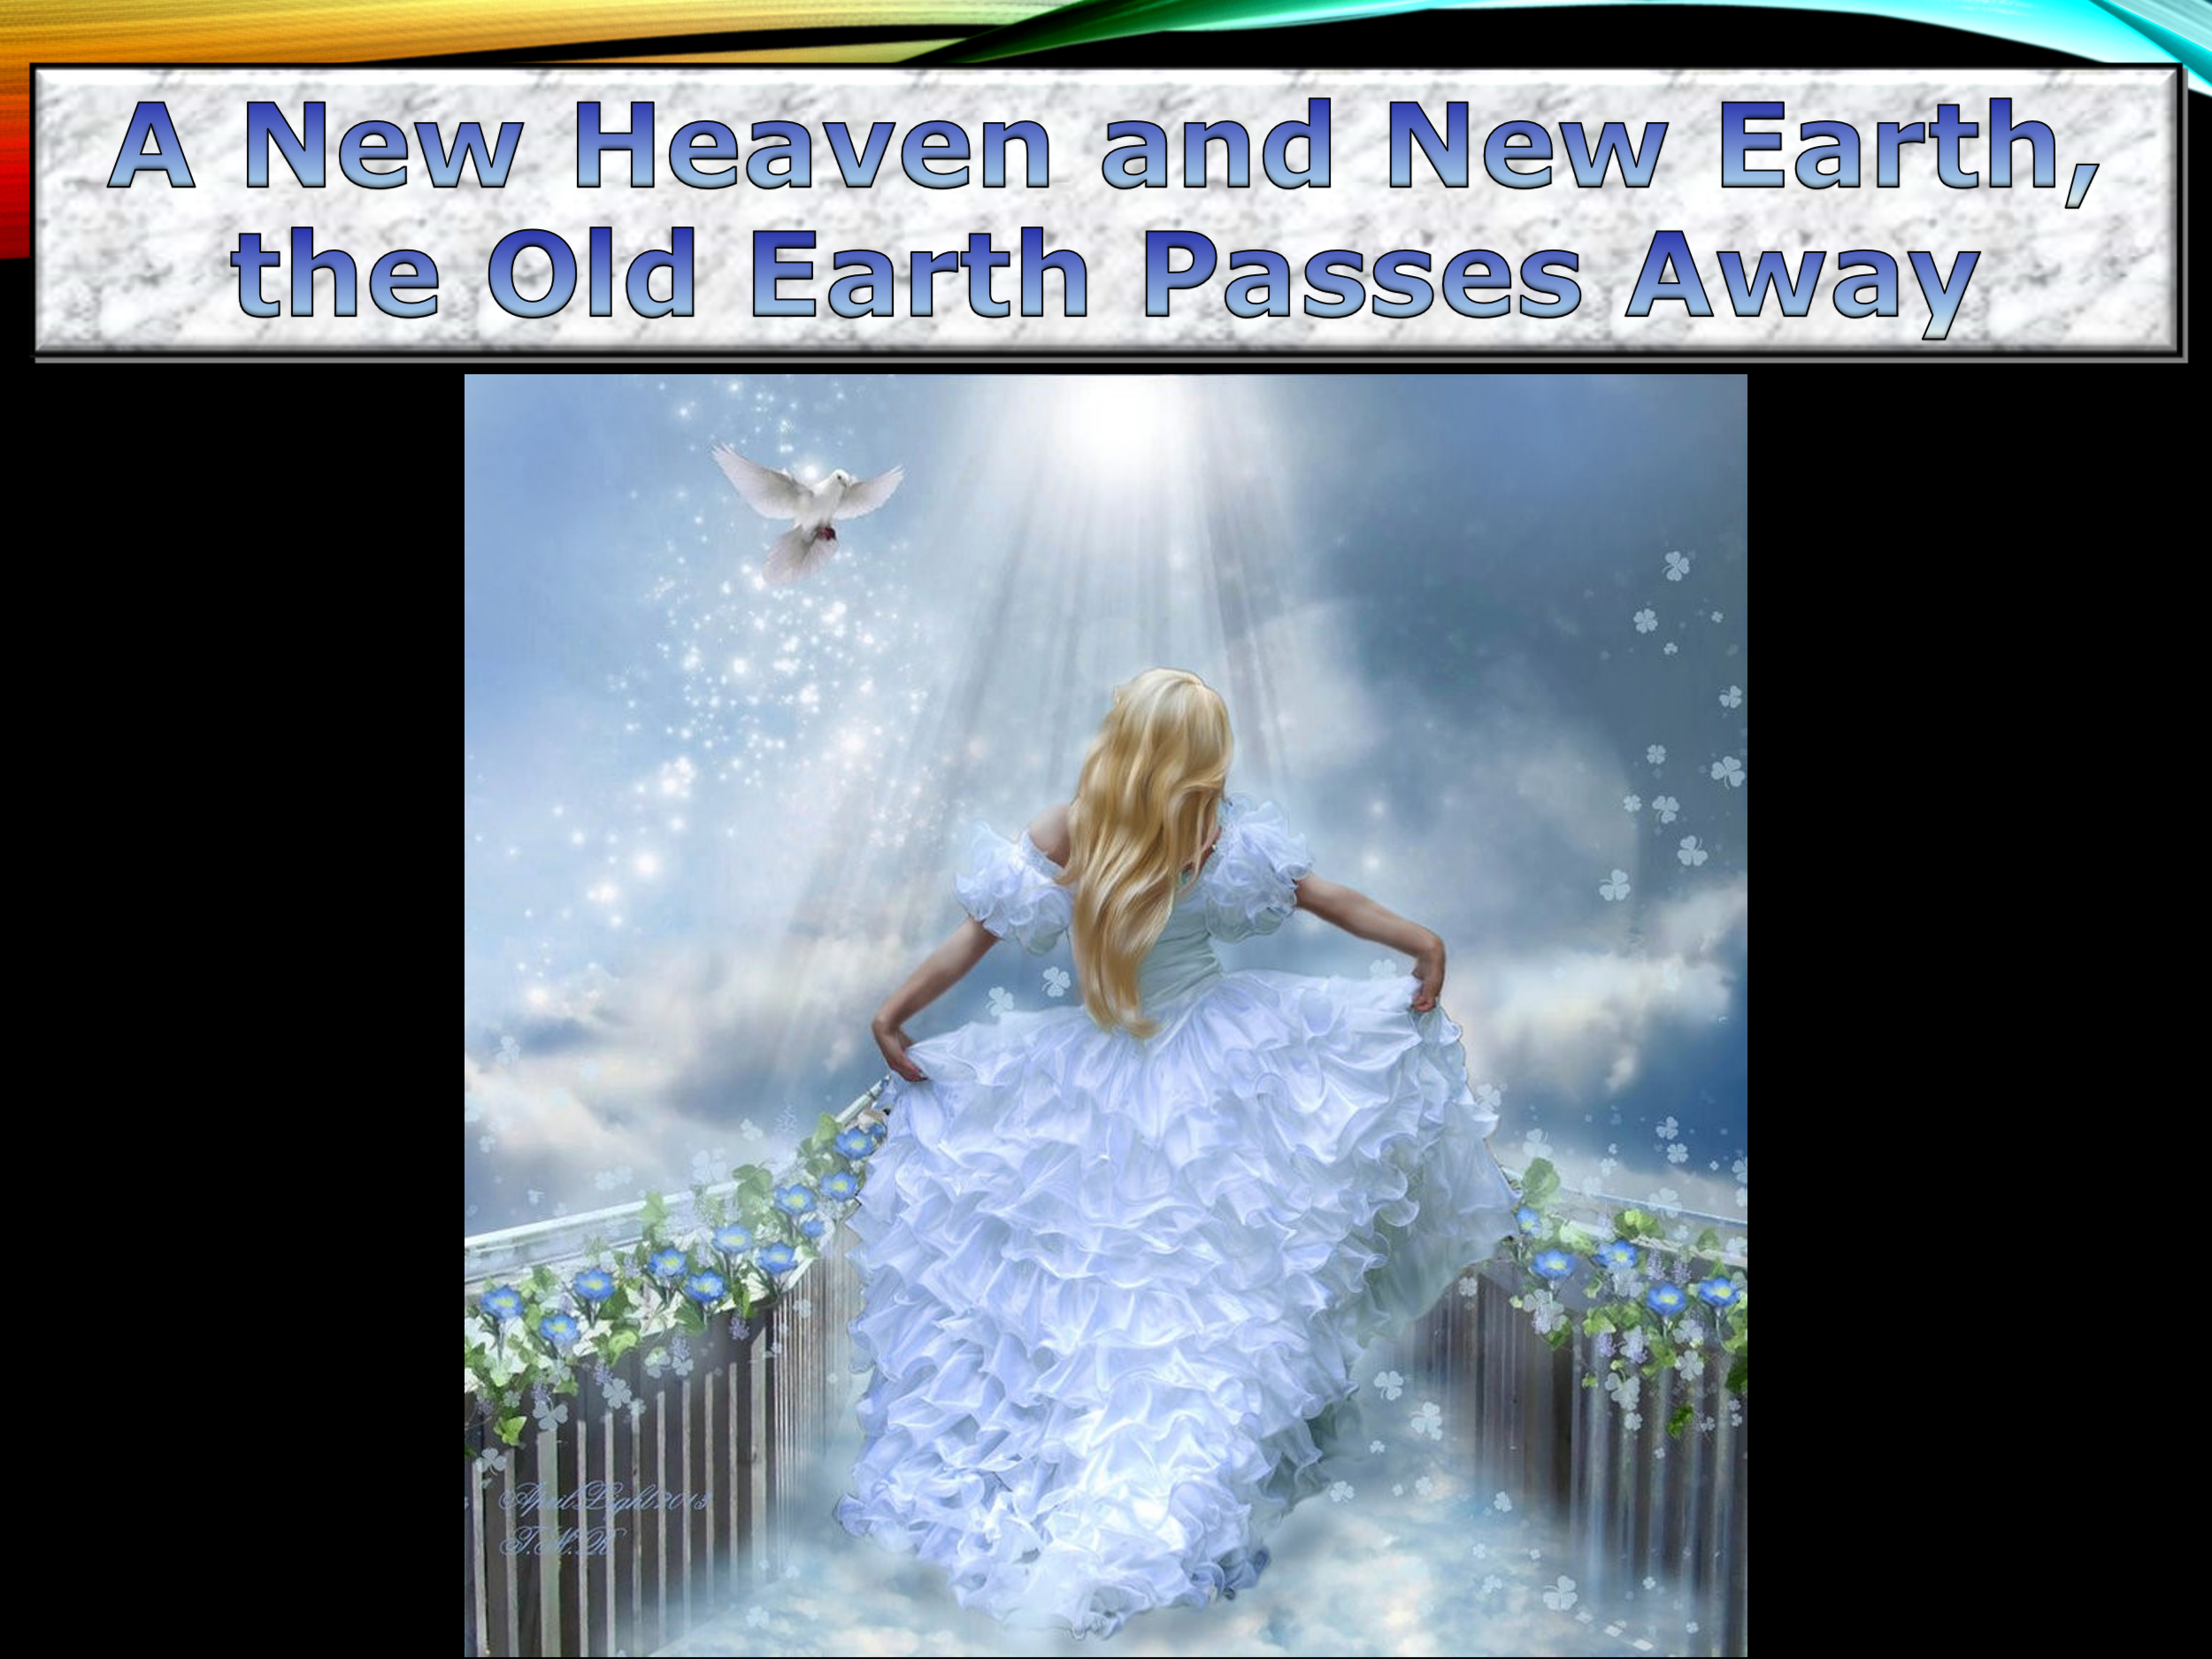
Bible Verse # | Bible Verse Text | Commentary
Matthew  9:18, 23-26  NIV  Mark 5:35, 39-42, NIV  Luke 8:49-56, NIV | Jesus Raises a Dead Girl …  … A synagogue leader came and knelt before him and said, My daughter has just died. But come and put your hand on her, and she will live.  When Jesus entered the synagogue leader’s house… he said, “Go away. The girl is not dead but asleep.” But they laughed at him … he went in and took the girl by the hand, and she got up. News of this spread through all that region.  Your daughter is dead, … The child is not dead but asleep. But they laughed at him… He took her by the hand and said to her, “Talitha koum!” (which means “Little girl, I say to you, get up!”). Immediately the girl stood up and began to walk around (she was twelve years old) … told them to give her something to eat.  Your daughter is dead, he said … Hearing this, Jesus said to Jairus, “Don’t be afraid; just believe, and she will be healed.” … Jesus said. “She is not dead but asleep.” They laughed at him, knowing that she was dead. But he took her by the hand and said, “My child, get up!” Her spirit returned, and at once she stood up. Then Jesus told them to give her something to eat. Her parents were astonished…. | When the girl’s physical body “died”, Jesus literally stated she was “asleep”, not awake.  Jesus resurrected the girl. Jesus said, “get up” she awakened, “she got up” and “stood up”, “began to walk” and “will live”.  The Bible never said that when she died, she was awake.  Furthermore, when her physical body died, her eternal soul didn’t die as Jesus correctly stated, her soul was asleep.  But the people were also correct. Her physical body was dead at the same time as Jesus described her soul as sleeping.  Both descriptions were correct at the same time. This resurrection is documented by 3 different Bible books, each book reveals further clues that physical death = spiritual sleep.
John 11:11-44 KJV | The Death of Lazarus  … Our friend Lazarus has fallen asleep; but I am going there to wake him up. … Jesus had been speaking of his death, but his disciples thought he meant natural sleep. So then he told them plainly, Lazarus is dead …  Jesus Comforts the Sisters of Lazarus  … Jesus found that Lazarus had already been in the tomb for four days… Lord, Martha said to Jesus, if you had been here, my brother would not have died. But I know that even now God will give you whatever you ask. Jesus said to her, Your brother will rise again. Martha answered, I know he will rise again in the resurrection at the last day.  Jesus said to her, I am the resurrection and the life. The one who believes in me will live, even though they die; and whoever lives by believing in me will never die. Do you believe this?  Yes, Lord, she replied, I believe that you are the Messiah, the Son of God, who is to come into the world.  When Mary reached the place where Jesus was and saw him, she fell at his feet and said, Lord, if you had been here, my brother would not have died…  Jesus Raises Lazarus From the Dead  Take away the stone, he said. But, Lord, said Martha, the sister of the dead man, by this time there is a bad odor, for he has been there four days …  When he had said this, Jesus called in a loud voice, Lazarus, come out! The dead man came out, his hands and feet wrapped with strips of linen, and a cloth around his face. Jesus said to them, Take off the grave clothes and let him go. | Jesus literally stated that Lazarus was both dead and asleep at the same time.  Both descriptions are correct, one description is for our physical body that literally dies, the other description is for our eternal spiritual body that only sleeps when we die.  Both descriptions are correct at the same time, because the Bible states that we have both a physical body that dies and an eternal spiritual body that sleeps, but never dies, I Cor. 15:42-44  The spiritual body of Lazarus was asleep, the physical body of Lazarus was dead and decaying in the tomb.  Jesus did not travel far off into the 1st Heaven to track down Lazarus, already awake in Heaven and having a good time. Jesus also didn’t have to convince Lazarus to return to his decrepit body on Earth and leave the eternal glory of Heaven.  Instead, the Bible states that Jesus went to the tomb of Lazarus on Earth and called his name. This agrees with other Bible verses that state that Jesus will call us, from our grave, at the resurrection.  Furthermore, Lazarus never described being awake in Heaven after he died.  Jesus again and again literally defines “rise” as “resurrected”, while “dead” is defined as being “asleep”.  Our spiritual body or soul never dies as Jesus stated, but it can sleep. The same as our physical body can sleep.  To ‘rise” is never erroneously defined in the Bible as being “asleep”.  Jesus is asked many time to clarify his comments on death. His literal clarification is that it is sleep.
I Cor. 11:30 KJV | That is why many among you are weak and sick, and a number of you have fallen asleep. | The Bible literally states 35 times that when the physical body dies, our spirit is asleep.  Physical death equals spiritual sleep for 99.999% of people, but not 100% of the people sleep when they die.
I Cor. 15:42-44 KJV | So also is the resurrection of the dead. It is sown in corruption; it is raised in incorruption:  It is sown a natural body; it is raised a spiritual body. There is a natural body, and there is a spiritual body. | This verse literally verifies that we have both a physical and spiritual body. Each body type reacts differently in death.  This is why Jesus always describes death as both physical body death and spiritual body sleep at the same time.
I Cor. 15:6 NIV | After that, he appeared to more than five hundred of the brothers and sisters at the same time, most of whom are still living, though some have fallen asleep. | This verse verifies again that when the physical body dies, the spirit is asleep.  This verse literally states that to be “living” is different from falling “asleep”.
Eph. 5:14 KJV | Wherefore he saith, Awake thou that sleepest, and arise from the dead, and Christ shall give thee light. | To “arise from the dead” is literally stated by the Bible to be awaked from sleep.  Our physical body dies per many Bible verses, but our soul is resurrected at the return of Jesus, or at judgement for the wicked.  A few other resurrection events also occur in the Bible. For example, 2 witnesses in 7 year tribulation are resurrected and rise to Heaven 3.5 days after they are killed. They are never described as awake while dead. Rev. 11:4-13
I Thes. 4:13-17 KJV | But I would not have you to be ignorant, brethren, concerning them which are asleep, that ye sorrow not, even as others which have no hope.  For if we believe that Jesus died and rose again, even so them also which sleep in Jesus will God bring with him.  For this we say unto you by the word of the Lord, that we which are alive and remain unto the coming of the Lord shall not prevent them which are asleep.  For the Lord himself shall descend from heaven with a shout, with the voice of the archangel, and with the trump of God: and the dead in Christ shall rise first:  Then we which are alive and remain shall be caught up together with them in the clouds, to meet the Lord in the air: and so shall we ever be with the Lord. | This verse literally states that those that die, sleep until the resurrection of Jesus, when we rise into the clouds.  This is stated in the ancient Greek Bible as “harpazo”, which means to snatch or take away the spirit in the original Hebrew scriptures. The ancient Latin Bible translation of this is “rapturo”, that is translated “rapture” in English.  This scripture states that the living & dead go to the 2nd Heaven in the clouds “together” at the same time, at the resurrection by Jesus.  There is no erroneous mention of our awake wandering spirits that already live in the 3rd Heaven, that must return to Earth, only to pick up our physical body from the grave.  Then we return to Heaven and only then do we have both our physical and spiritual body.  This illegal theory violates many Bible verses, including that no human has entered the 3rd Heaven.
2 Cor. 12: 2-4  John 3:13 KJV | I knew a man in Christ above fourteen years ago, (whether in the body, I cannot tell; or whether out of the body, I cannot tell: God knoweth;) such an one caught up to the third heaven.  How that he was caught up into paradise, and heard unspeakable words, which it is not lawful for a man to utter.  And no man hath ascended up to heaven, but he that came down from heaven, even the Son of man which is in heaven. | The Apostle John literally states that no human is awake today and living permanently in this highest 3rd Heaven.  But God has allowed a few people with near death experiences (described in this verse) to temporarily visit the 1st Heaven here on Earth in another dimension, or the 3rd Heaven, (remotely through a vision while still in their body in Earth). God allows this experience to tell others of Heaven’s existence.
II Cor: 5:6-9 KJV | Therefore we are always confident, knowing that, whilst we are at home in the body, we are absent from the Lord …  We are confident, I say, and willing rather to be absent from the body, and to be present with the Lord. Wherefore we labour, that, whether present or absent, we may be accepted of him. | This Bible verse is also correct. The latest science proves ALL Bible verses about death were correct. We can’t throw out Bible verses we don’t understand. ALL Bible verses are required to understand the complex science of Heaven.  This is analogous to a wife that is present with her husband when she sleeps beside him in bed.  She is physically present with him, but mentally asleep at the same time and knows nothing that occurs around her. Both descriptions are 100% correct at same time.  If we read the rest of II Cor. 5:9 it confirms that we may be “absent” from the body (dead), but not yet “accepted” (judged as righteous to enter Heaven).  This verse disproves that all Christians who die, immediately go to Heaven.  We aren’t immediately sent to live in heaven for eternity after our death. Otherwise, the resurrection (rapture) at Jesus’ 2nd coming has no importance. It would only be a minor distraction from our life of eternal bliss, already living in Heaven.
Ecclesiastes 9:5  Psalms 115:17 KJV  Psalms 146:4 KJV | For the living know that they shall die: but the dead know not any thing, neither have they any more a reward; for the memory of them is forgotten.  The dead praise not the Lord, neither any that go down into silence.  His breath goeth forth, he returneth to his earth; in that very day his thoughts perish. | These verses all confirm that you are aware of nothing on Heaven or Earth after death, until you are awakened by Jesus, at the resurrection.
Matthew 24:50-54 KJV | Jesus, when he had cried again with a loud voice, yielded up the ghost.  And, behold, the veil of the temple was rent in twain from the top to the bottom; and the earth did quake, and the rocks rent;  And the graves were opened; and many bodies of the saints which slept arose, And came out of the graves after his resurrection, and went into the holy city, and appeared unto many.  Now when the centurion, and they that were with him, watching Jesus, saw the earthquake, and those things that were done, they feared greatly, saying, Truly this was the Son of God. | This was an ancient past rapture when Jesus was crucified and resurrected after the cross.  These resurrected saints lived before the time of Jesus, but were resurrected from their graves at the same time as Jesus was resurrected.  These resurrected saints are never again mentioned on Earth, after their resurrection.  This is because these ancient saints were no longer on Earth. Jesus took them to Heaven with Him, as the firstfruits, exactly as stated literally in 1 Cor. 15:20-24.  Before they were resurrected, these ancient saints were also described as sleeping. We cannot throw these verses out, that state over and over that after you die you sleep.
John 5:25-29 KJV | Verily, verily, I say unto you, The hour is coming, and now is, when the dead shall hear the voice of the Son of God: and they that hear shall live.  For as the Father hath life in himself; so hath he given to the Son to have life in himself;  And hath given him authority to execute judgment also, because he is the Son of man.  Marvel not at this: for the hour is coming, in the which all that are in the graves shall hear his voice,  And shall come forth; they that have done good, unto the resurrection of life; and they that have done evil, unto the resurrection of damnation. | This verse also clarifies that we are not awake after we die celebrating in Heaven far off in the universe.  We hear the call to our resurrection from our gravesite, here on Earth.
Daniel 12:2 KJV | And many of them that sleep in the dust of the earth shall awake, some to everlasting life, and some to shame and everlasting contempt. | The fact that we “sleep in the dust” of “the Earth” is conclusively proven in this verse. This literally says that we sleep on Earth, not in Heaven. The Biblical evidence is overwhelming.
Mat. 25:1-12  Rev. 4:1 | “And at midnight a cry was heard: ‘Behold, the bridegroom is coming; go out to meet him!’ Then all those virgins arose and trimmed their lamps. And the foolish said to the wise, ‘Give us some of your oil, for our lamps are going out.’ But the wise answered, saying, ‘No, lest there should not be enough for us and you; but go rather to those who sell, and buy for yourselves.’ And while they went to buy, the bridegroom came, and those who were ready went in with him to the wedding; and the door was shut.”  (Apostle John) After this I looked, and, behold, a door was opened in heaven: and the first voice which I heard was as it were of a trumpet talking with me; which said, Come up hither, and I will shew thee things which must be hereafter. | The 5 wise virgins enter a doorway (wormhole) to another dimension, while in the wilderness on Earth at the end time rapture. They see a great wedding feast of believers, then the door shuts.  The most advanced science today shows that both our spiritual and physical bodies are connected, at the same physical location, across 2 different dimensions, through doorways mentioned often in the Bible, (Mark 1:10, Act 7:54).  After death our dead physical body, connected to our spiritual body (I Cor. 15:44), remains at our gravesite in this dimension on Earth.  Although at the same geographical location, our spiritual body sleeps protected by God in a different Heavenly dimension & knows nothing.  This is the 1st Heaven that is biblically & scientifically proven to be all around us here on Earth.  For example, the door to Heaven that opened for the Apostle Steven, John and Jacob’s ladder to a Heavenly door, were all seen in the sky above Earth, not in a distant galaxy.  Science today proves there are 10 or 11 dimensions all around us. We can slightly open these doors (wormholes), but only at nano sized levels. No human can pass through. Only God can open these doors for humans.  Refer to the book “End Time Events Heaven & Hell pg. 614-624, also “Evolution Is Not Science” Ch. 22 “Time & Matter”, that confirms time and space described literally in the Bible.
Ecclesiastes 12:7 | Then shall the dust return to the earth as it was: and the spirit shall return unto God who gave it. | This verse literally confirms that the physical body and spiritual body are each treated differently after death.
Revelation 6:9-11 | And when he had opened the fifth seal, I saw under the altar the souls of them that were slain for the word of God, and for the testimony which they held:  And they cried with a loud voice, saying, How long, O Lord, holy and true, dost thou not judge and avenge our blood on them that dwell on the earth?  And white robes were given unto every one of them; and it was said unto them, that they should rest yet for a little season, until their fellowservants also and their brethren, that should be killed as they were, should be fulfilled. | The Bible stated that a few people are awakened briefly after their first death, to see their fate. Then they return to sleep awaiting judgement.  For example, the souls (spiritual bodies) of the holy Martyrs under God’s throne are present with God in Heaven after their death. They are briefly awakened to speak “how long”, then told to go back to “rest” and wait a little longer.  When humans “rest”, they “sleep” for a short time, that is also called a nap. Jesus confirms this in Mat. 26:45
1 Cor. 15:20-24 | But Christ has indeed been raised from the dead, the firstfruits of those who have fallen asleep. For since death came through a man, the resurrection of the dead comes also through a man.  For as in Adam all die, so in Christ all will be made alive. But each in turn: Christ, the firstfruits (with 1st resurrection of dead saints); then, when he comes, those who belong to him (2nd resurrection of dead when Jesus returns for church, before end times).  Then the end will come, when he hands over the kingdom to God the Father after he has destroyed all dominion, authority and power. | Paul literally said that when the physical body of the descendants of “Adam” are “dead”, their soul has “fallen asleep”.  Paul also clarifies that at the end time resurrection, the physical body has a “resurrection”, while at the same time the spiritual body is awakened from being “asleep”.  These verses mention a second resurrection (rapture), Christ first with the ancient saints (described above) who lived before Jesus, as stated in Mat. 27:50-54.  These ancient saints had their 1st resurrection at the same time as Jesus was resurrected from the cross.  The next rapture will be the saved people of the church, (who die after the time of Jesus). They experience their 1st resurrection, at end time rapture when Jesus returns.
Luke 23:39-43 | And one of the malefactors which were hanged railed on him, saying, If thou be Christ, save thyself and us.  But the other answering rebuked him, saying, Dost not thou fear God, seeing thou art in the same condemnation?  And we indeed justly; for we receive the due reward of our deeds: but this man hath done nothing amiss.  And he said unto Jesus, Lord, remember me when thou comest into thy kingdom.  And Jesus said unto him, Verily I say unto thee, Today shalt thou be with me in paradise. | But the Bible clearly states that not everyone sleeps after death.  The thief on the cross was promised to be in the paradise of Heaven that same day, while crucified on the cross with Jesus.  The small group of people the Bible literally mentions who are awake in the 1st or 2nd Heaven dimension on Earth include: Elijah, Moses, Lazarus the beggar (Luke 16:19-31), Enoch, the thief on the cross (Luke 23:40-43) Abraham (Luke 16:19-31) and all the ancient saints resurrected with Jesus (Mat. 27:52-54)  They are described in the two lower levels of Heaven, (called Heaven, paradise or Abraham’s bosom). They are not sleeping in the grave, as all others are after they die.  But only Jesus ascended from Earth to enter the highest 3rd level of Heaven. I Cor. 12:2 NIV Jesus entered the Holy of Holies in Heaven at that time. Heb. 9:11-14, 21-28 NIV  Also all the martyrs under the throne of God are also briefly awakened in Heaven.
Isaiah 14:9-20 | Hell from beneath is moved for thee to meet thee at thy coming: it stirreth up the dead for thee, even all the chief ones of the earth; it hath raised up from their thrones all the kings of the nations.  All they shall speak and say unto thee, Art thou also become weak as we? art thou become like unto us?  Thy pomp is brought down to the grave, and the noise of thy viols: the worm is spread under thee, and the worms cover thee.  How art thou fallen from heaven, O Lucifer, son of the morning! how art thou cut down to the ground, which didst weaken the nations! …  Yet thou shalt be brought down to hell, to the sides of the pit.  They that see thee shall narrowly look upon thee, and consider thee, saying, Is this the man that made the earth to tremble, that did shake kingdoms;  That made the world as a wilderness, and destroyed the cities thereof; that opened not the house of his prisoners?  All the kings of the nations, even all of them, lie in glory, every one in his own house.  But thou art cast out of thy grave like an abominable branch, and as the raiment of those that are slain, thrust through with a sword, that go down to the stones of the pit; as a carcase trodden under feet.  Thou shalt not be joined with them in burial, because thou hast destroyed thy land, and slain thy people: the seed of evildoers shall never be renowned. | Nebuchadnezzar is also briefly awakened in the grave, in the dimension of Hell on Earth, along with ALL other ancient evil rulers.  This is describing the 1st level of Hell that has “ground”, “graves”, “worms” at the ”sides (of) the (bottomless) pit”.  This does not describe the deepest level of Hell, that is down in the bottom of that pit, that is the eternal lake of lava fire after judgement.  The near death temporary experiences of the 1st Heaven and Hell, by a small number of people, both in the Bible and today also verifies this.  These near death temporary experiences are discussed in detail in “Evolution Is Not Science” Chapter 28 “Prayer, Angels and Miracles Prove Evolution Wrong”.  Reference also the book “End Time Events Heaven & Hell” pgs. 491-528, 568 to 585 and 603-613.
Luke 16:19-31 | The Rich Man and Lazarus  There was a rich man who was dressed in purple and fine linen and lived in luxury every day. At his gate was laid a beggar named Lazarus, covered with sores and longing to eat what fell from the rich man’s table. Even the dogs came and licked his sores.  “The time came when the beggar died and the angels carried him to Abraham’s side. The rich man also died and was buried. In Hades, where he was in torment, he looked up and saw Abraham far away, with Lazarus by his side.  So he called to him, ‘Father Abraham, have pity on me and send Lazarus to dip the tip of his finger in water and cool my tongue, because I am in agony in this fire.’  “But Abraham replied, ‘Son, remember that in your lifetime you received your good things, while Lazarus received bad things, but now he is comforted here and you are in agony. And besides all this, between us and you a great chasm has been set in place, so that those who want to go from here to you cannot, nor can anyone cross over from there to us.’  “He answered, ‘Then I beg you, father, send Lazarus to my family, for I have five brothers. Let him warn them, so that they will not also come to this place of torment.’  “Abraham replied, ‘They have Moses and the Prophets; let them listen to them.’  “‘No, father Abraham,’ he said, ‘but if someone from the dead goes to them, they will repent.’  “He said to him, ‘If they do not listen to Moses and the Prophets, they will not be convinced even if someone rises from the dead.’” | The 1st Heaven dimension on Earth is where Lazarus the beggar went when he died. Lazarus is one of a few people who are awake after death. He saw Abraham. He also saw the rich man far off in a temporary burning hell.  This describes the lowest temporary 1st Heaven on Earth, without the throne of God.  This is NOT describing the highest 3rd Heaven, where Jesus said that no human has entered and contains the throne of God. John 3:13  Those who erroneously claim that we immediately enter the 3rd Heaven at death, violate 35 Bible verses, plus John 3:13, that literally state that we instead sleep or rest after death.  There are also different levels of Hell literally stated in the Bible. The Bible and near-death experiences both describe that Hell (Hades) is only the 1st level of Hell.  After judgement and the 1,000 year reign of Christ, the entire temporary place called Hell, is thrown into the lake of fire. Rev. 20:10,14  Hell is a temporary hot semi-molten rock layer located “besides” the “bottomless pit”, that leads to the much deeper hotter lake of liquid lava fire, deep in the Earth.  After judgement all demons and condemned evil humans will be thrown into this Lake of Fire.  Today we can prove scientifically that deep within the Earth is a literal lake of fire, from nuclear fusion reactions at tremendous pressure. These nuclear reactions will heat this lava for billions of years in the future.  The Bible also describes “gates” to enter Hell, deep in the earth. But how can liquid lava, hot enough to melt steel and rock, have a physical gate.  The answer is that the Bible is again describing a doorway to a different dimension. But this dimensional doorway is to Hell and the lake of fire.  Rock in the Earth or lava could not imprison a demon. They can pass through solid rock. But the gates of Hell are doorways to another dimension at that hot location.  Only dimensional doorways can imprison demons.  Refer to the book “End Time Events Heaven & Hell” pgs. 491-528, 568-585 & 603-613.

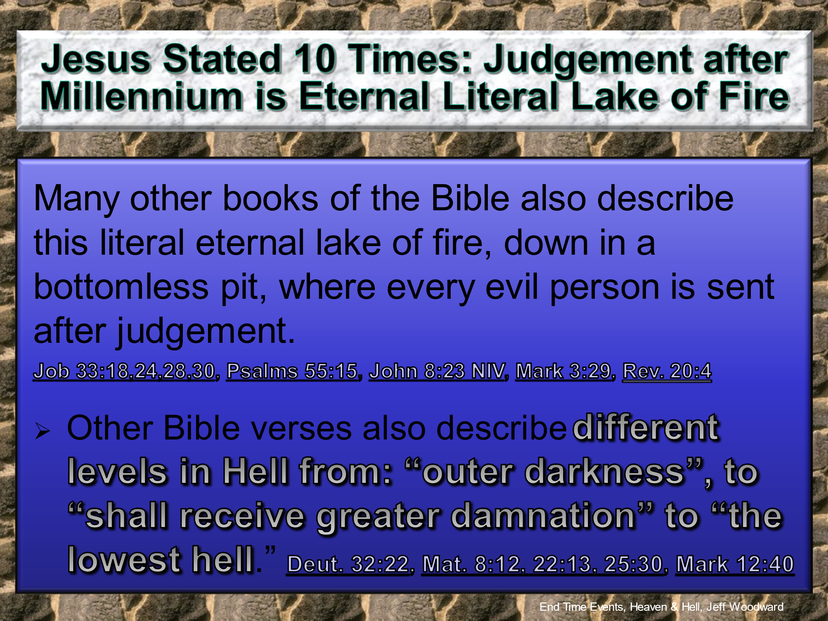
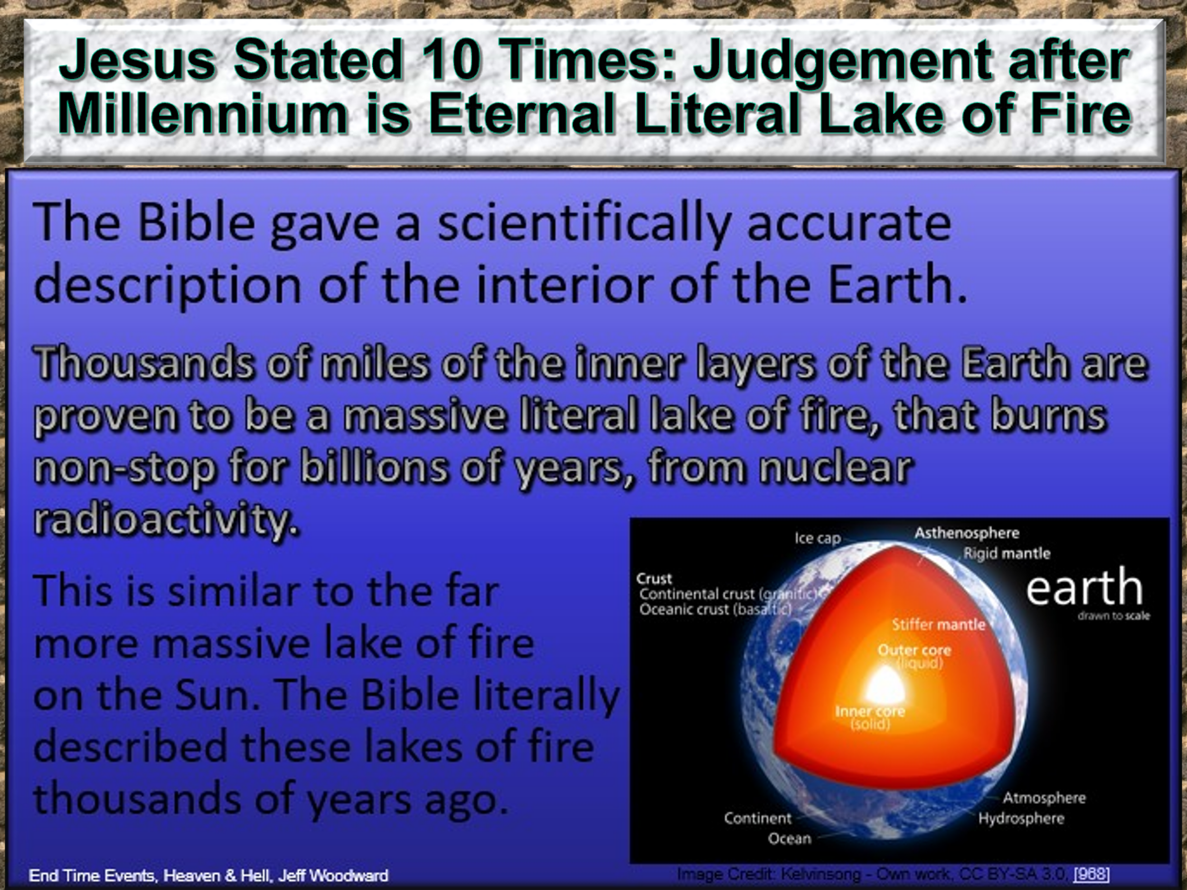
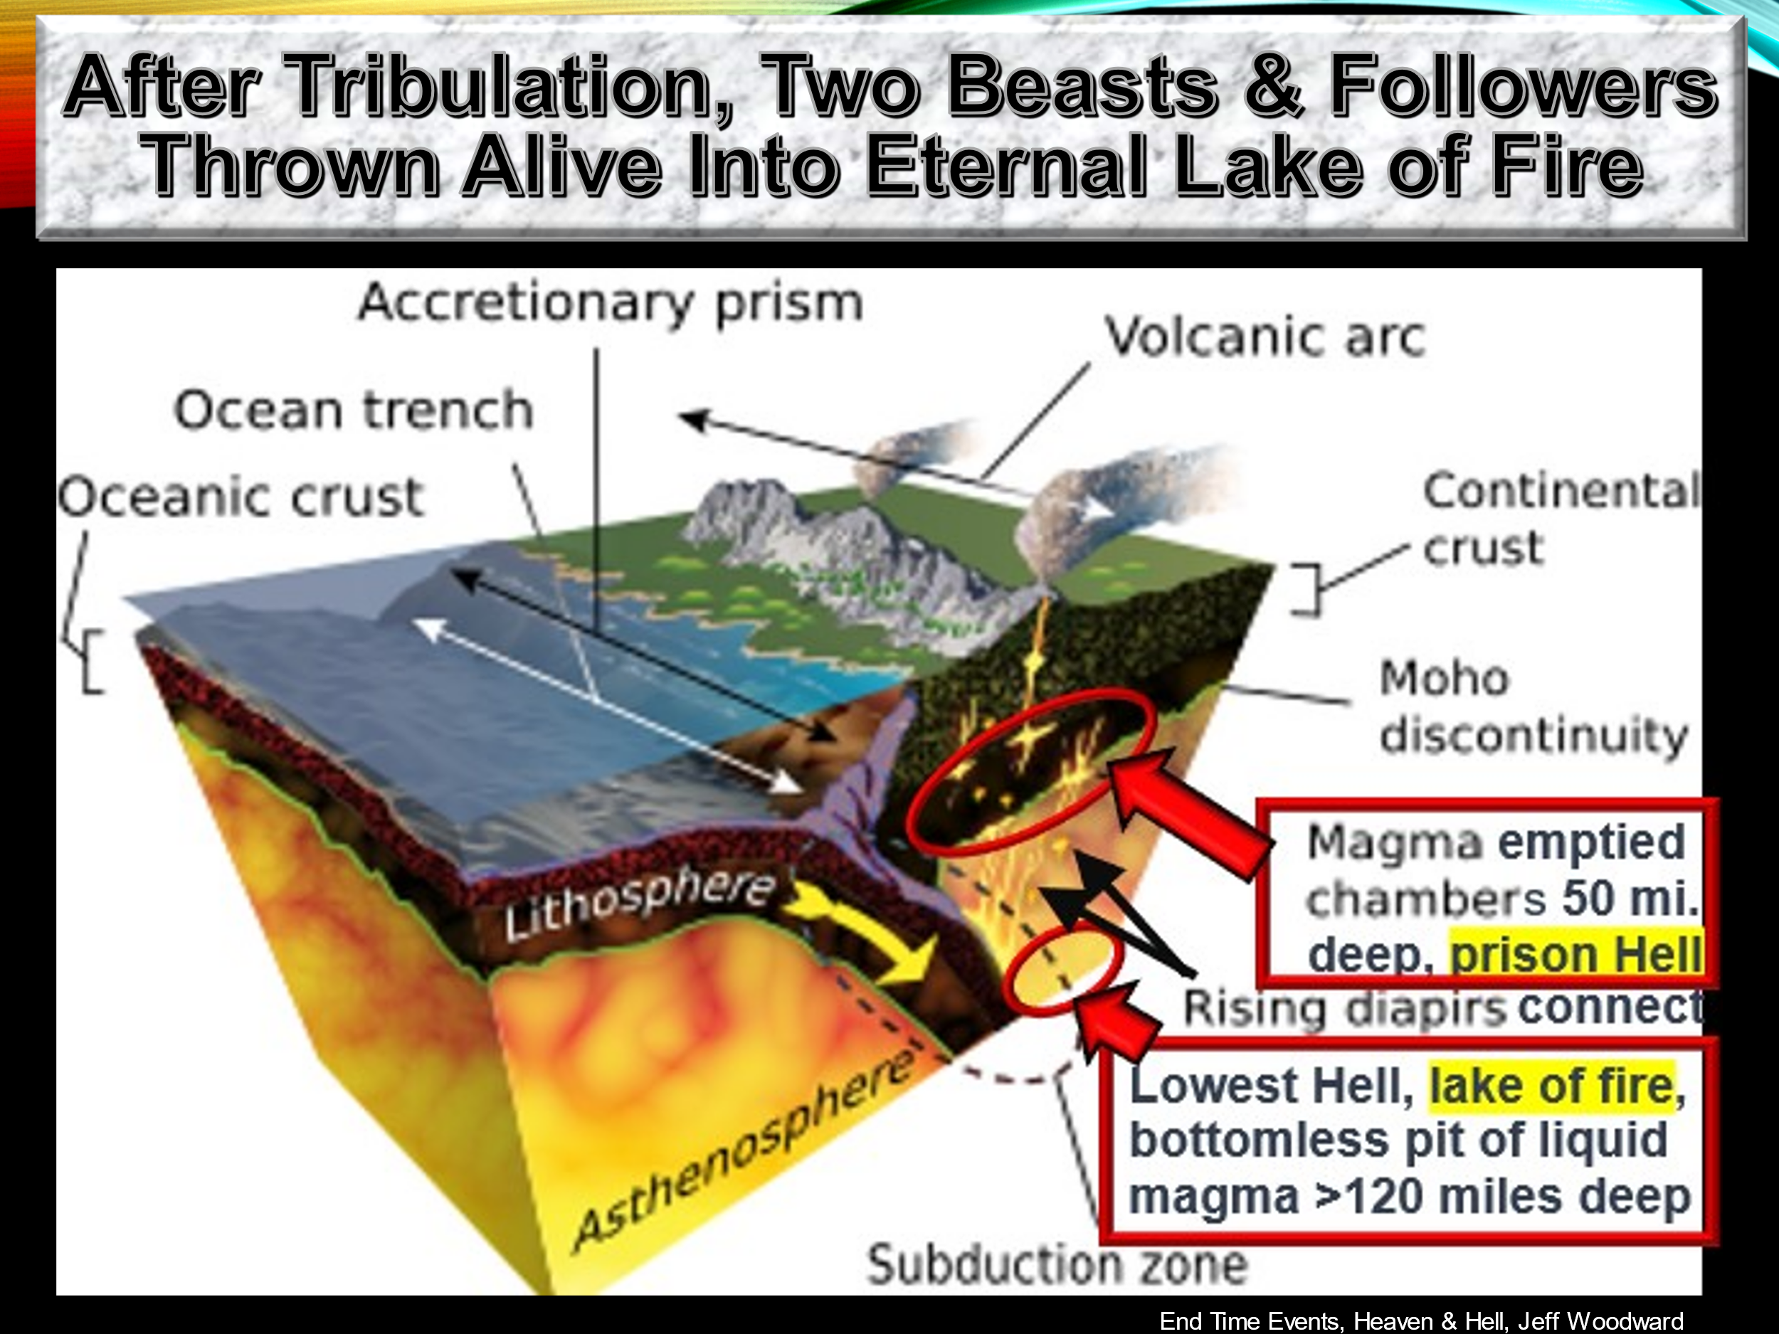
These Bible verses and events are rigorously proven scientifically in the books “End Time Events, Heaven & Hell” pgs. 24-49, 50-55, 115-145, 491-528, 568-585, 603-624 and “Evolution Is Not Science” Chapters 22, 23, 28 and 30.
Copyright © 2024 by Jeff Woodward, all rights reserved.
No part of this publication may be reproduced or transmitted in any way by any means – electronic, mechanical, photocopy, recording, or otherwise – without the prior permission of the copyright holder, except as provided by USA copyright law.
All Bible references are from the King James Bible from Zondervan Corporation L.L.C. unless stated otherwise. Scripture quotations marked (NIV) are taken from Holy Bible, New International Version®, NIV®. Copyright © 1973, 1978, 1984, 2011, by Biblica, Inc. ™ Used by permission of Zondervan. All rights reserved worldwide. www.zondervan.com ”NIV” and “New International Version” are trademarks registered in US Patent and Trademark Office by Biblica, Inc. ™

